S.K.R COLLEGE FOR WOMEN, RJAMAHENDRAVARAM
DEPARTMENT OF SOCIOLOGY
BESTPRACTICE -2018-19

COMMUNITY SERVICE –ANGANWADI CENTRE

INTRODUCTION:

The Department of sociology has conducted a regular best activity Community Service is in this year on 17-08-2018 at ANGANWADI CENTRE, limgampeta , Rajamahendravaram . In this activity students observed about Anganwadi centres and duties of Anganwadi workers.

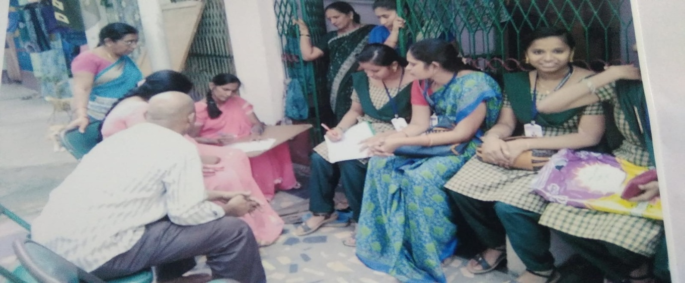

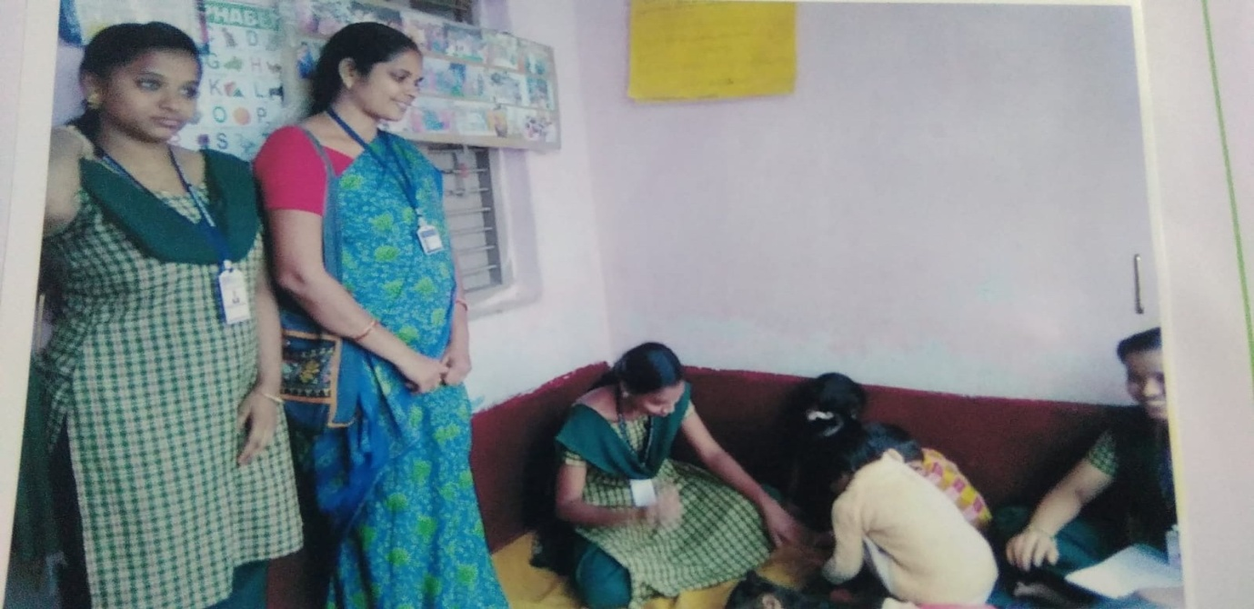

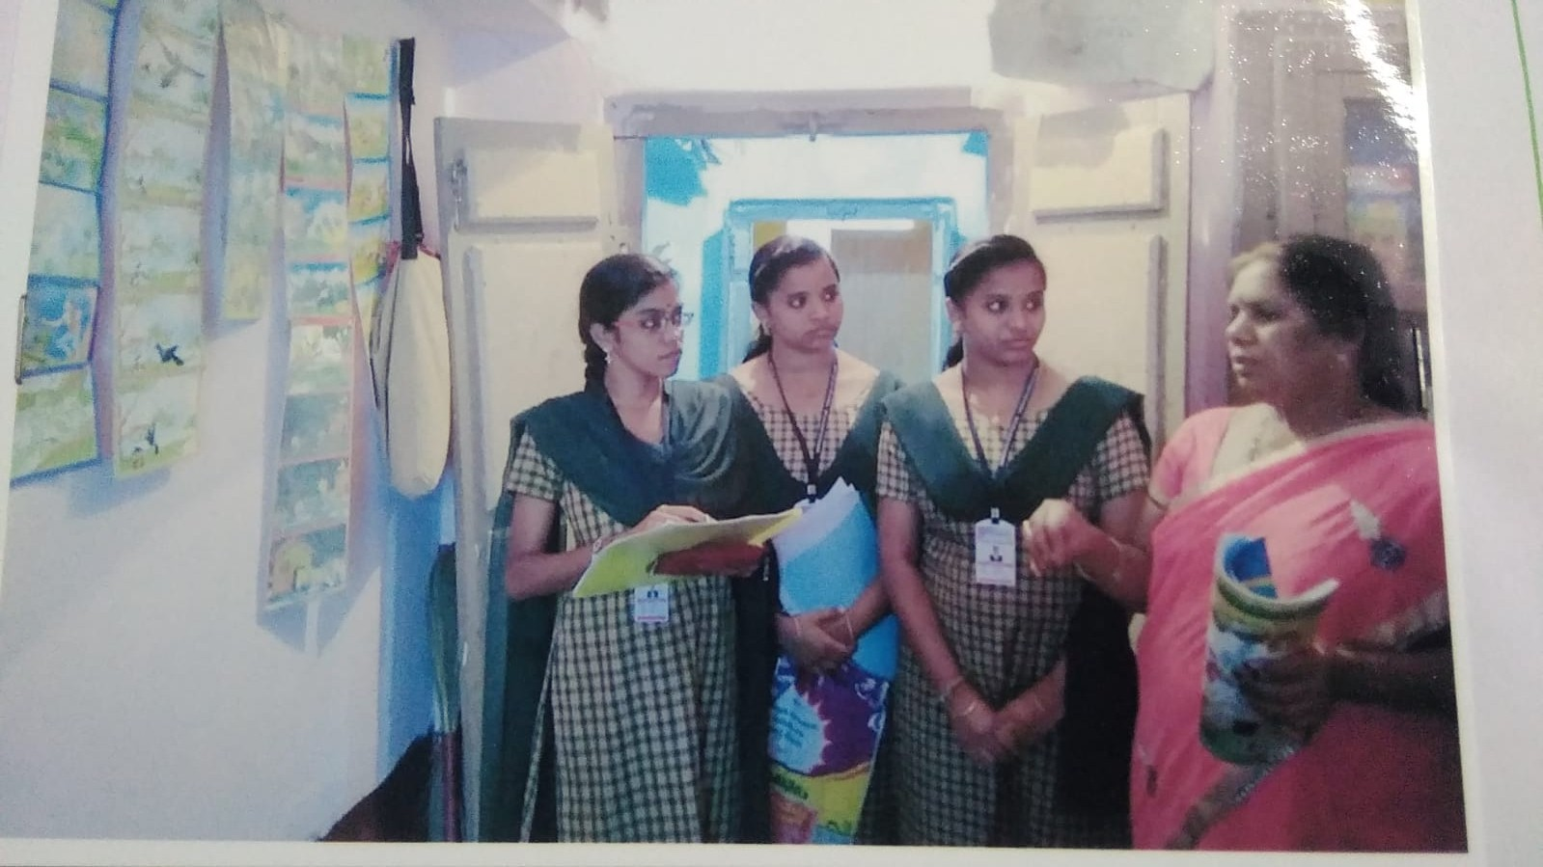

OBJECTIVES:
To create awareness
• The primary aim of this practice is to mobilize the students in a good manor and improve their social responsibility and personality development
• This is the way of enhancing classroom learning by making real world connections
• To know the community service, Humanity and charity
• Benefit to students, boost self confidence , increase motivation, encourage good behaviour and broaden their horizons

CONCLUSION:

Through this Activity students gain and learned about carrier opportunities . They identified the Government provide provisions to child and pregnant Ladies. Finally the younger generation change their mindset and improve their social values .

