S.K.R.COLLEGE FOR WOMEN, RAJAMAHENDRAVARAM
DEPARTMENT OF SOCIOLOGY-BEST PRACTICE-2019-20
JANANI MENTALLY HANDICAPPED ORGANISATION
INTRODUCTION:

The Department of sociology has conducted a regular best activity Community Service is in this year on 11-2-2020 at JANANI MENTALLY HANDECAPPED ORGANIZATION (DISABBLED SCHOOL) . In this activity students recognized every human being got their success only with their Mental courage.

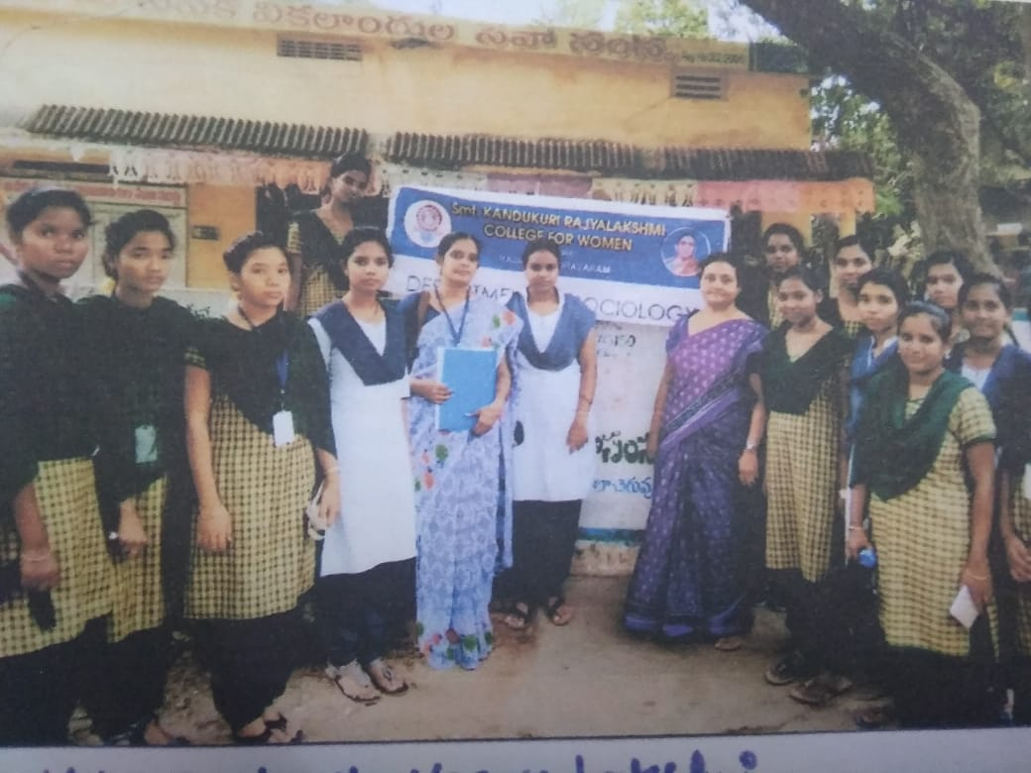

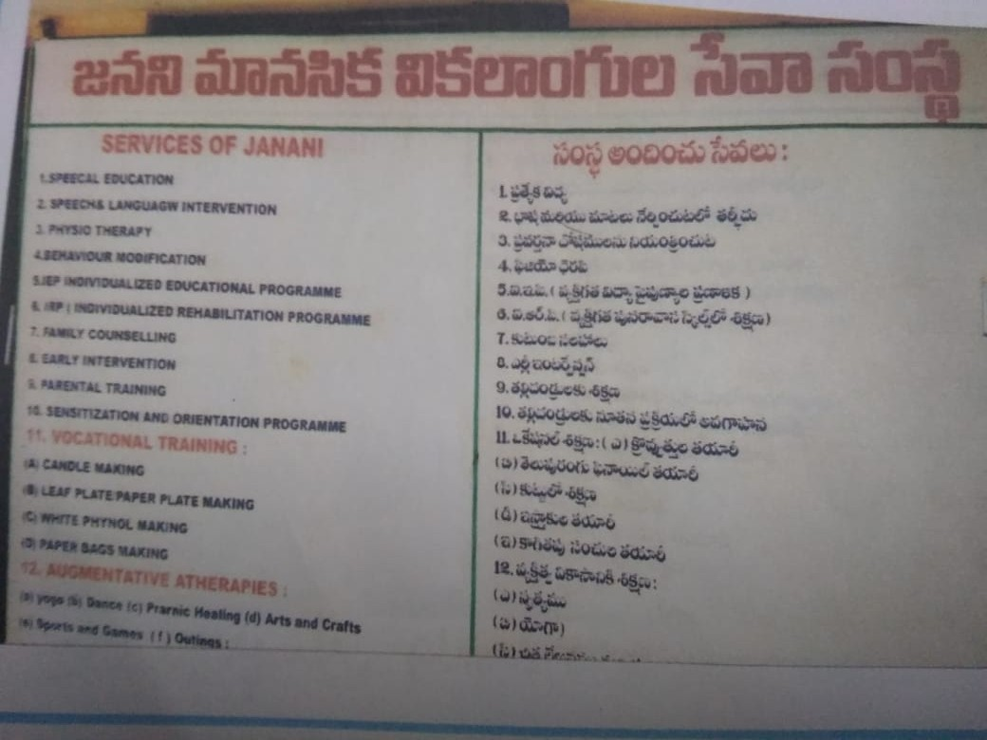
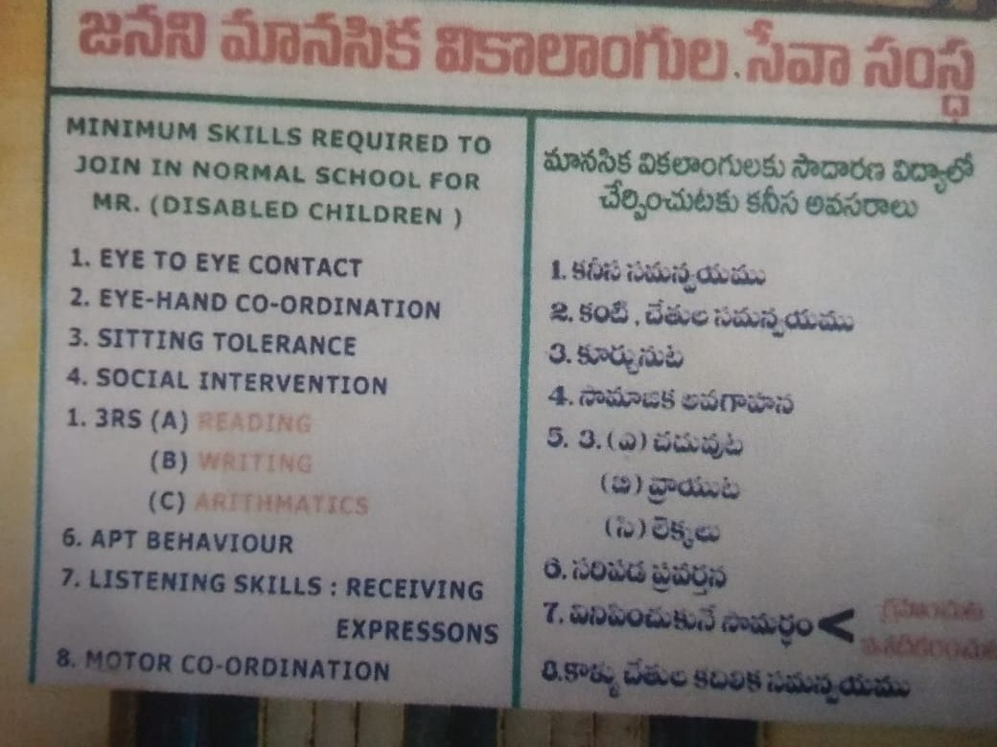

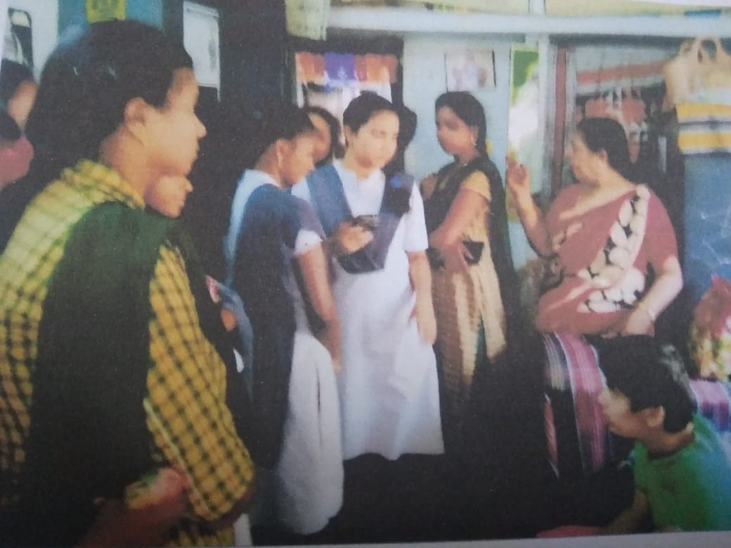

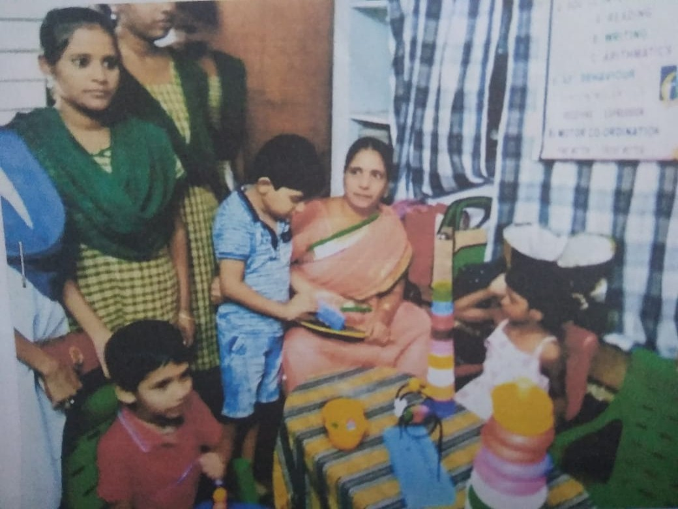

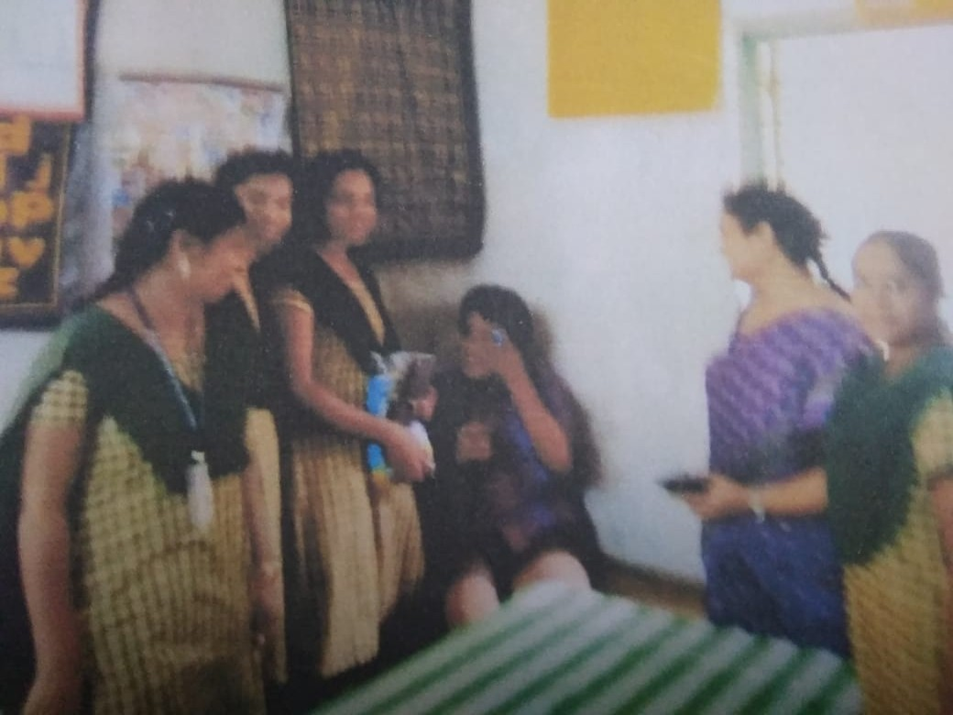

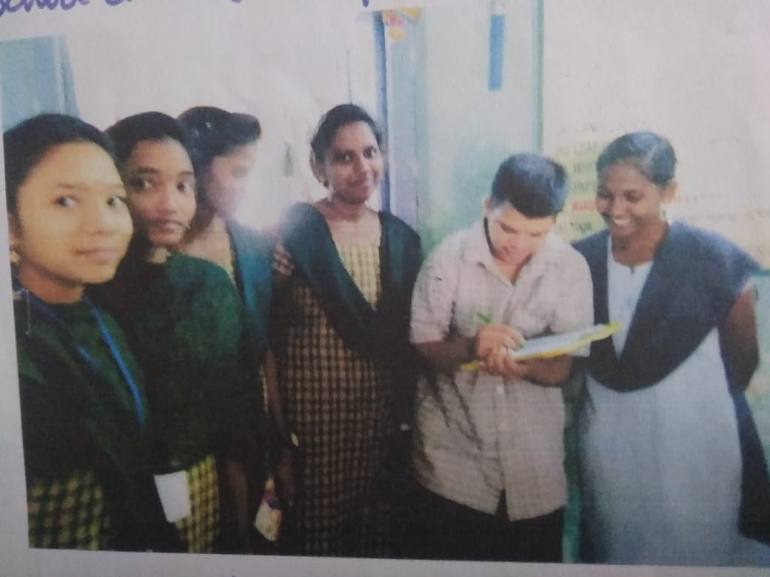

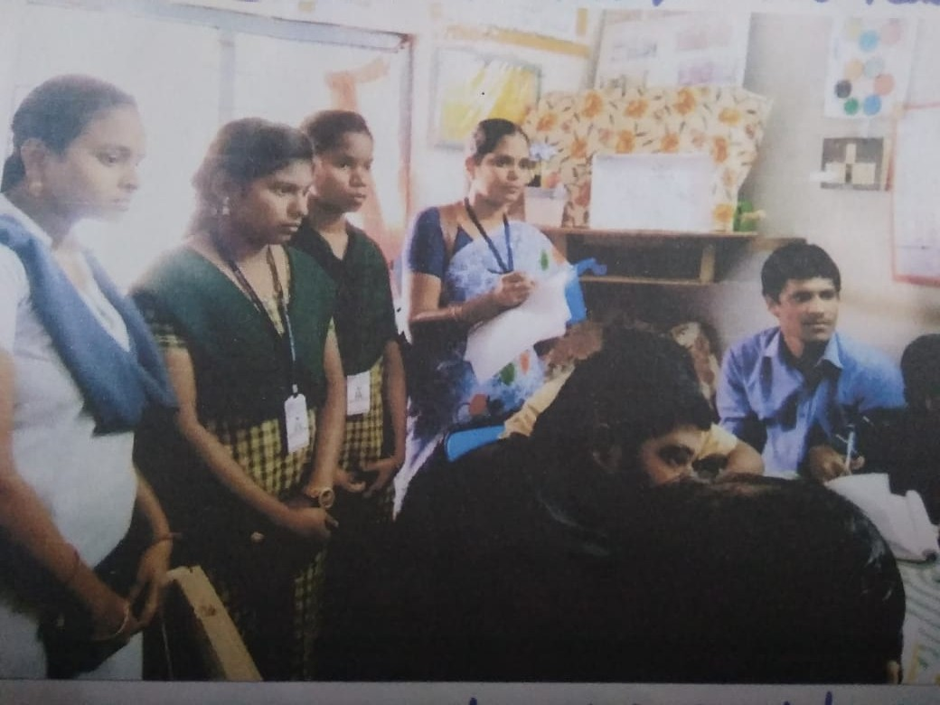

OBJECTIVES:
To create awareness and importance of social service
• The primary aim of this practice is to mobilize the students in a good manor and improve their social responsibility and personality development
• This is the way of enhancing classroom learning by making real world connections
• To know the community service, Humanity and charity
• Benefit to students, boost self confidence , increase motivation, encourage good behaviour and broaden their horizons

CONCLUSION:

This activity expose and communicate to students different types of people are living in the Society and a human being can achieve anything he wants. Finally the younger generation change their mindset and improve their social values .

