S.K.R COLLEWGE FOR WOMEN, RJAMAHENDRAVARAM
DEPARTMENT OF SOCIOLOGY
BESTPRACTICE 2021-22
COMMUNITY SERVICE –OLD AGE HOME

INTRODUCTION:

The Department of sociology has conducted a regular best activity Community Service is in this year on 3-3-2022 at KASTURIBA GANDHI SEVA SAMGAM (OLD AGE HOME) . In this activity students recognize and learn affection of elders and importance of joint family.
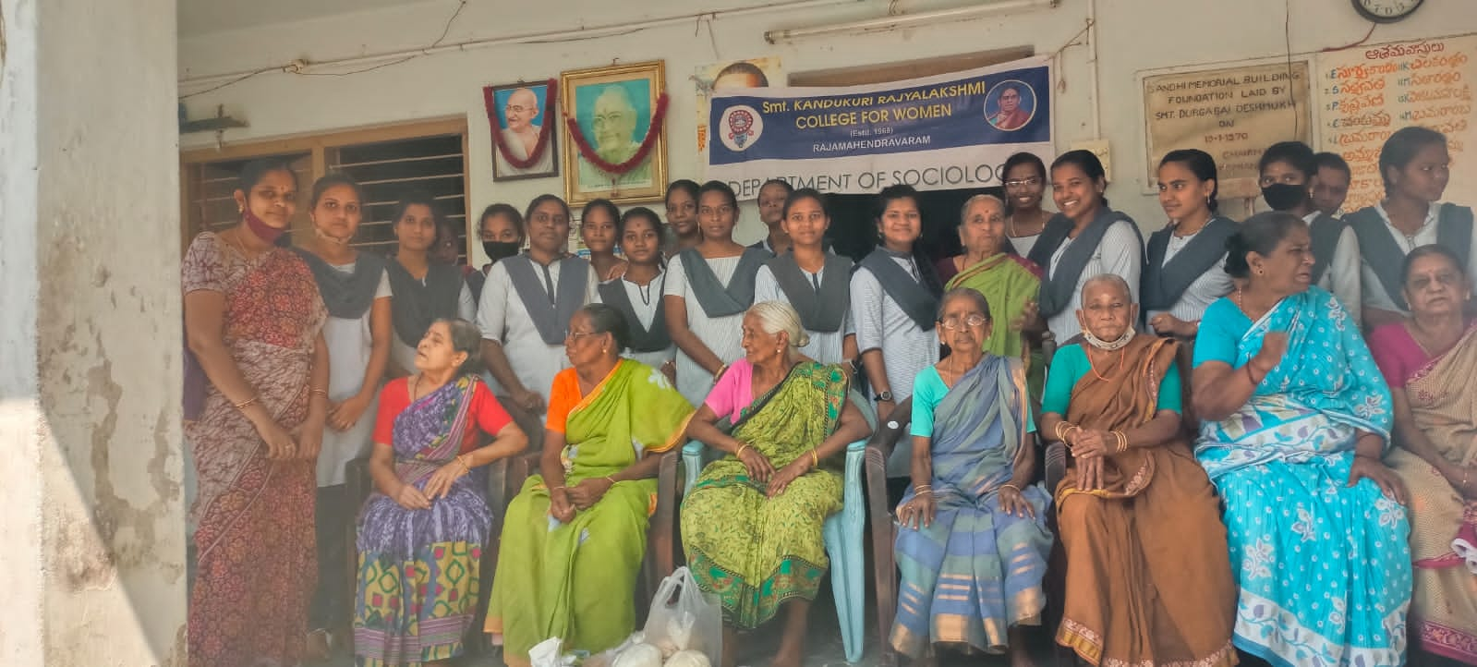
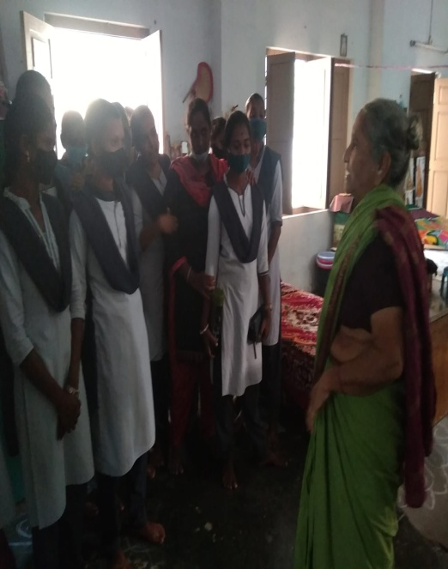
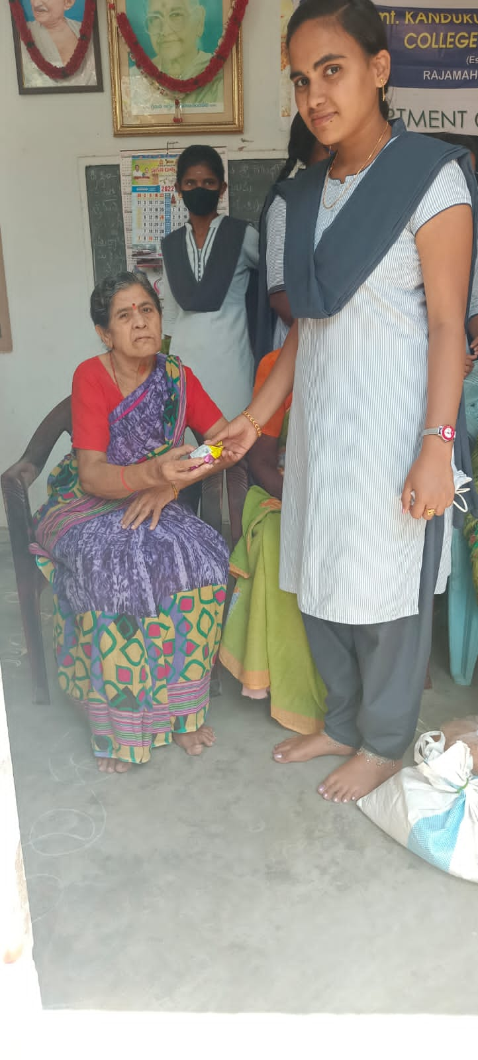
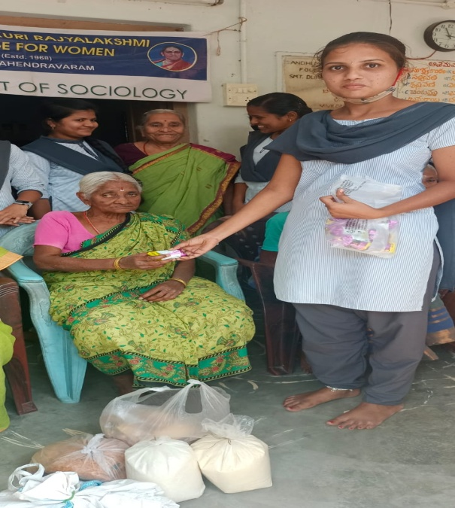
OBJECTIVES:
To create awareness and important of joint family
• The primary aim of this practice is to mobilize the students in a good manor and improve their social responsibility and personality development
• This is the way of enhancing classroom learning by making real world connections
• To recognize the experiences of old age people and taken inspiration to them
• To know the community service, Humanity and charity
• Benefit to students, boost self confidence , increase motivation, encourage good behaviour and broaden their horizons

CONCLUSION:

This activity expose and communicate to students different life styles and support to joint family system. They identified through the old age homes what we loss of Human values and moral values of human beings .Finally the younger generation change their mindset and improve their social values .

