S .K.R.GOVERNMENT DEGREE COLLEGE (W) , RAJAMAHENDRAVARAM
DEPARTMENT OF SOCIOLOGY
BEST PRACTICE-2022-23
ACTIVITY OF CHARITY—JOY OF GIVING-child home
Department of Sociology has conducted an activity of Charity—Joy of giving at BALASADAN established by Raobahadur Sri Kandukuri Veeresalimgam Panthulugaru. Sociology students has distributed Note Books , Drawing stationery and Refreshments to the Children on 10-11-2022.
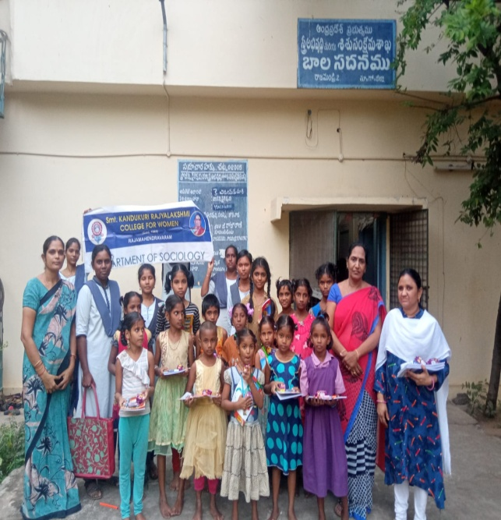
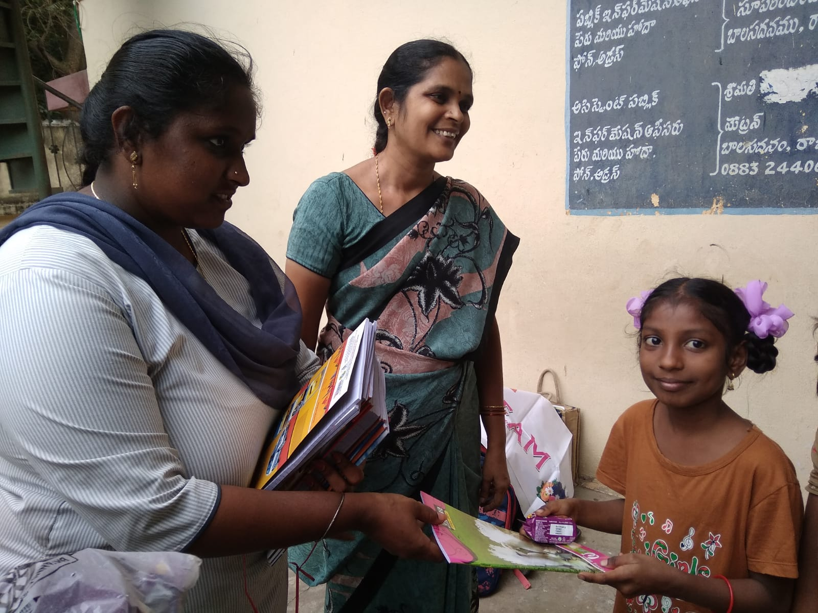

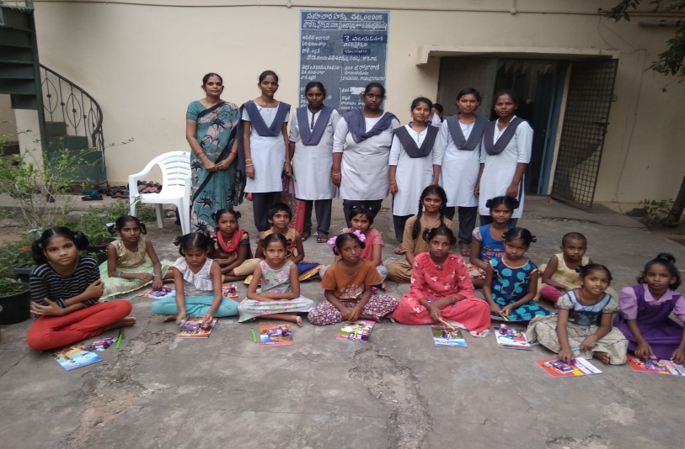

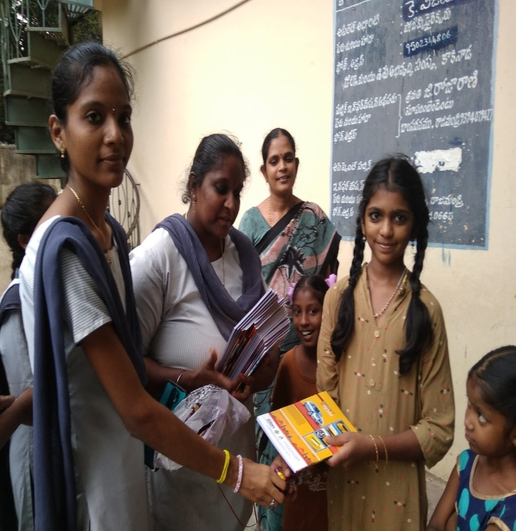

OBJECTIVES:
To create awareness on CHARITY
• The primary aim of this practice to mobilize the students in a good manor joy of giving , improve their social responsibility and personality development
• This is the way of enhancing classroom learning by making real world connections
• To recognize the child aims and ambitions give a support to them
• To know the community service, Humanity and charity
• Benefit to students, boost self confidence , increase motivation, encourage good behaviour and broaden their horizons

CONCLUSION:

This activity expose and communicate to students different life styles and learn give a support the child homes and to develop Human values and moral values of human beings .Finally the younger generation change their mindset and improve their social values

