S.K.R GOVERNMENT DEGREE COLLEGE, (W) RJAMAHENDRAVARAM
DEPARTMENT OF SOCIOLOGY
BESTPRACTICE-2022-23
GOWTHAMI JEEVAKARUNYA SAMGAM (Children’s Orphanage)

INTRODUCTION:

Department of sociology has conducted a regular best activity in this year on 23-02-2023 at GOWTHAMI JEEVAKARUNYA SAMGAM (Children’s Orphanage), Godavari bund , Rajamahendravaram . In this activity students observed shelter to the Orphan Children. They learn about Charity , Community Service and Humanity.

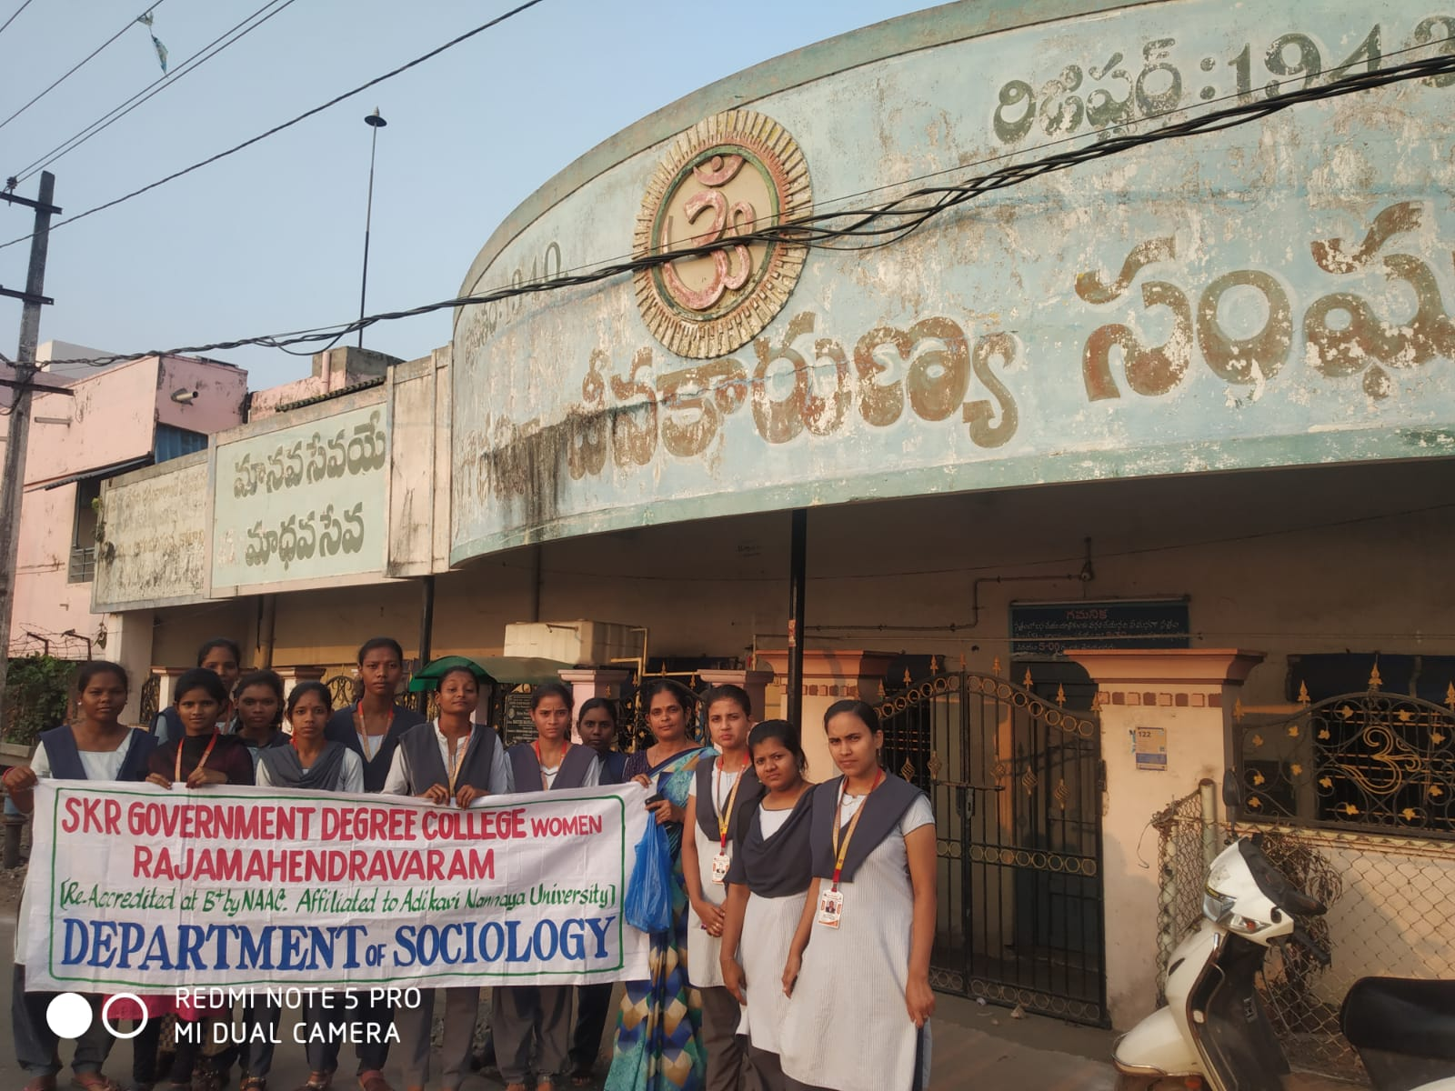
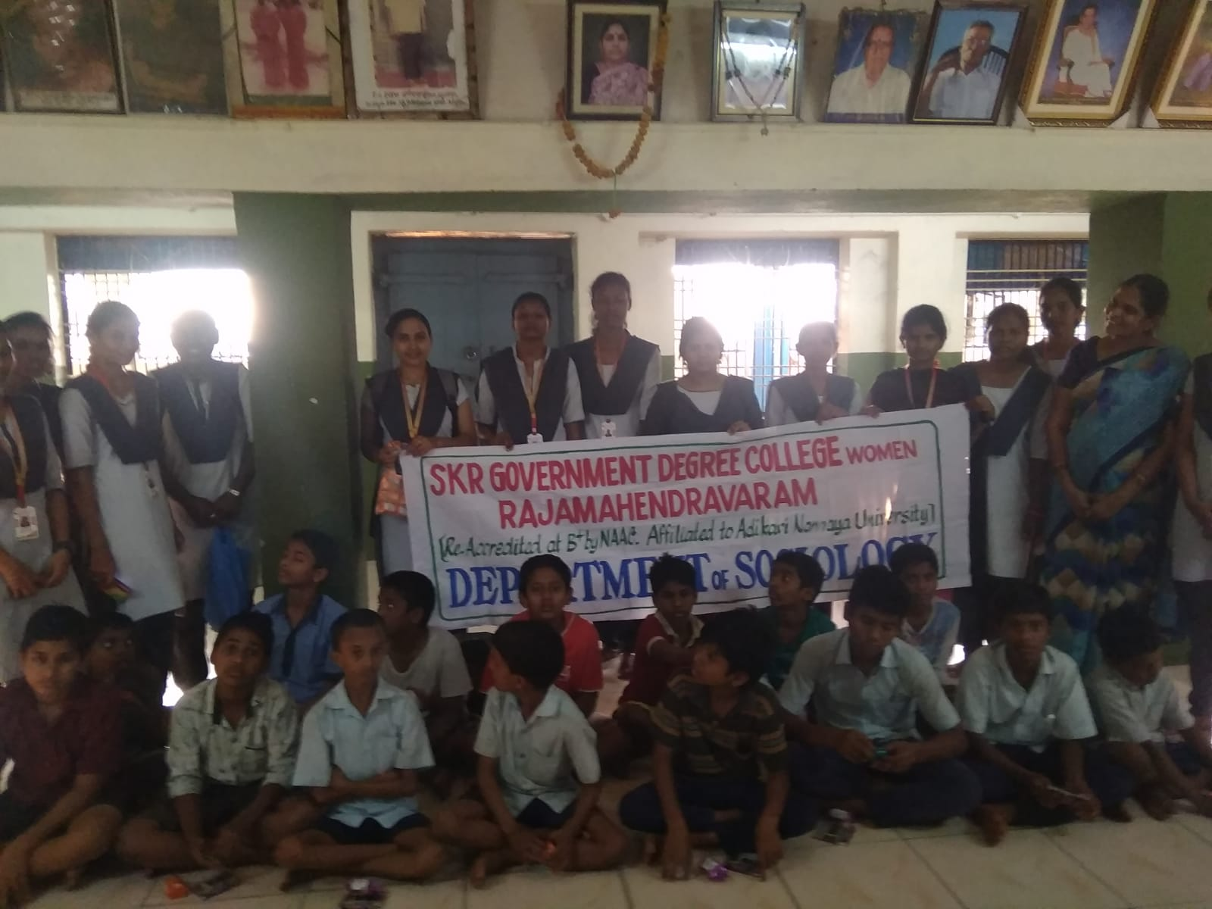

OBJECTIVES:
To create awareness
• The primary aim of this practice is to mobilize the students in a good manor and improve their social responsibility and personality development
• This is the way of enhancing classroom learning by making real world connections
• To know the community service, Humanity and charity
• Benefit to students, boost self confidence , increase motivation, encourage good behaviour and broaden their horizons

CONCLUSION:

In this activity students showing kindness , express love and affection to others ..Finally the younger generation change their mindset and improve their Human, Moral and social values .

