SKR GOVT DEGREE COLLEGEFOR WOMEN
DEPARTMENT OF TELUGU
2020-21
DEPARTMENTAL BEST PRACTICES
Our Final year students completed a project work on “THOLUBOMMALAATA”.They searched the charecters of Tholubommalu like Srirama,Ravana,Juttupoligaadu etc…from google and make a file about the Tholubommalaata.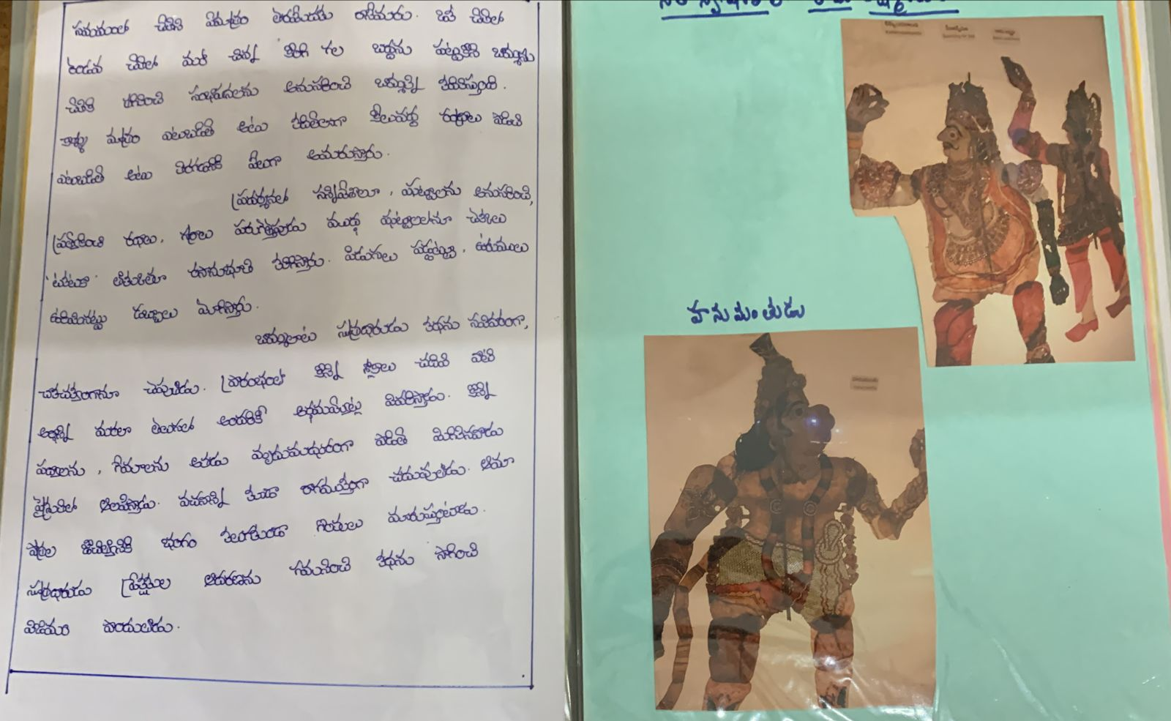

Ramayanam: Kishkindakanda

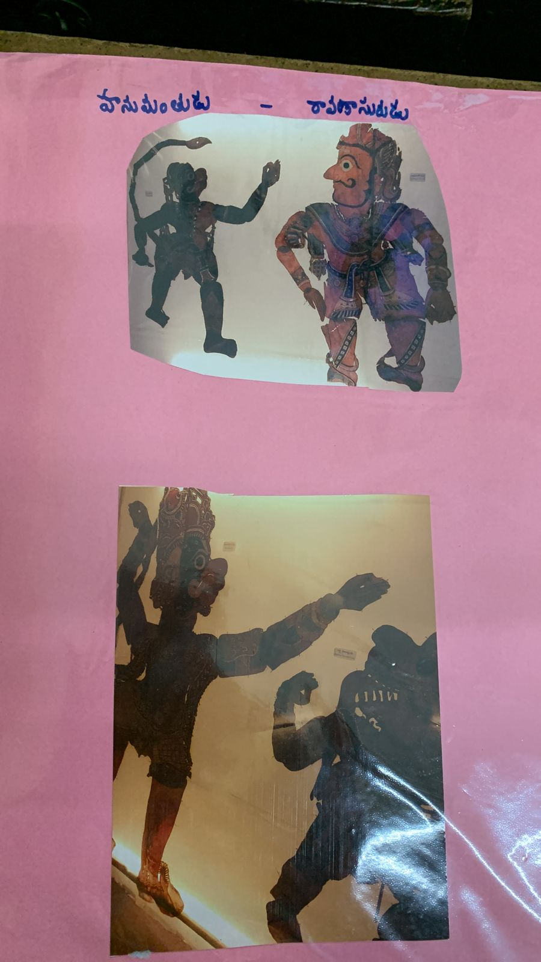

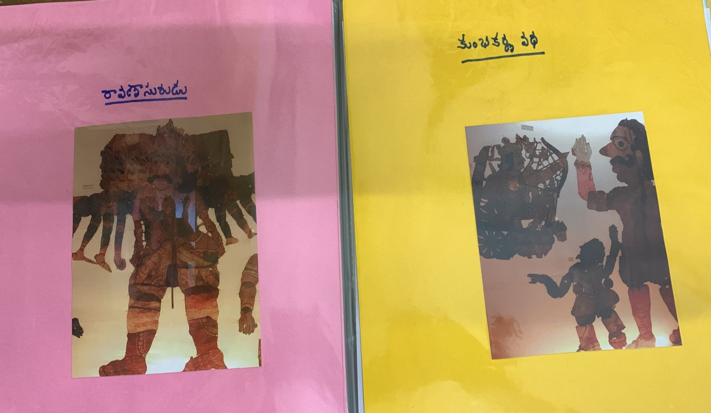

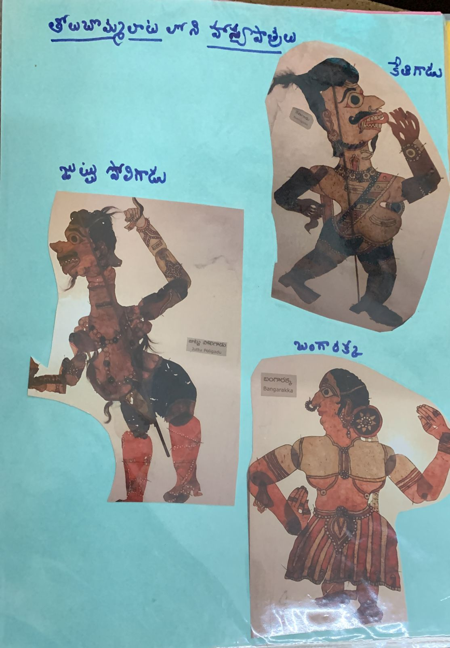
Comedy Charecters in Tholubommalaata.1.Juttupoligaadu
2.Bangarakka, Kethigadu

Best Practice-2

Our Final BA students make a project in JOURNALISM. They collected various paper cuttings like as headings,Editorials,Leads…etc
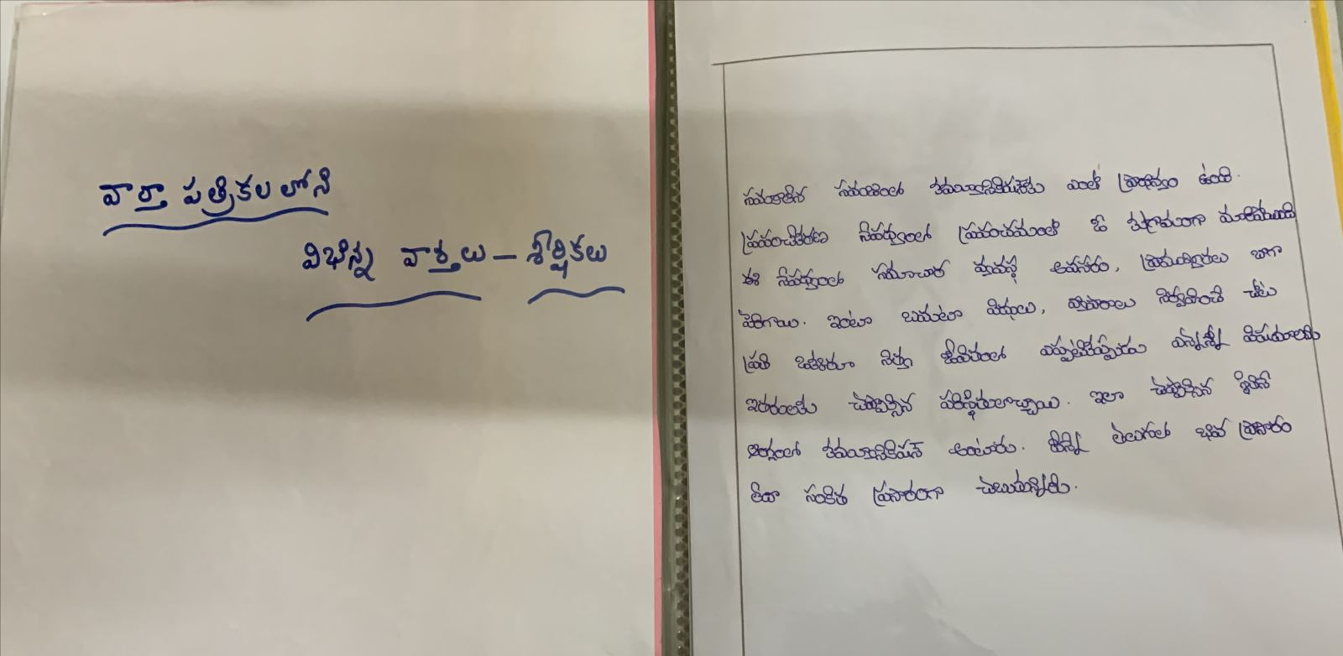
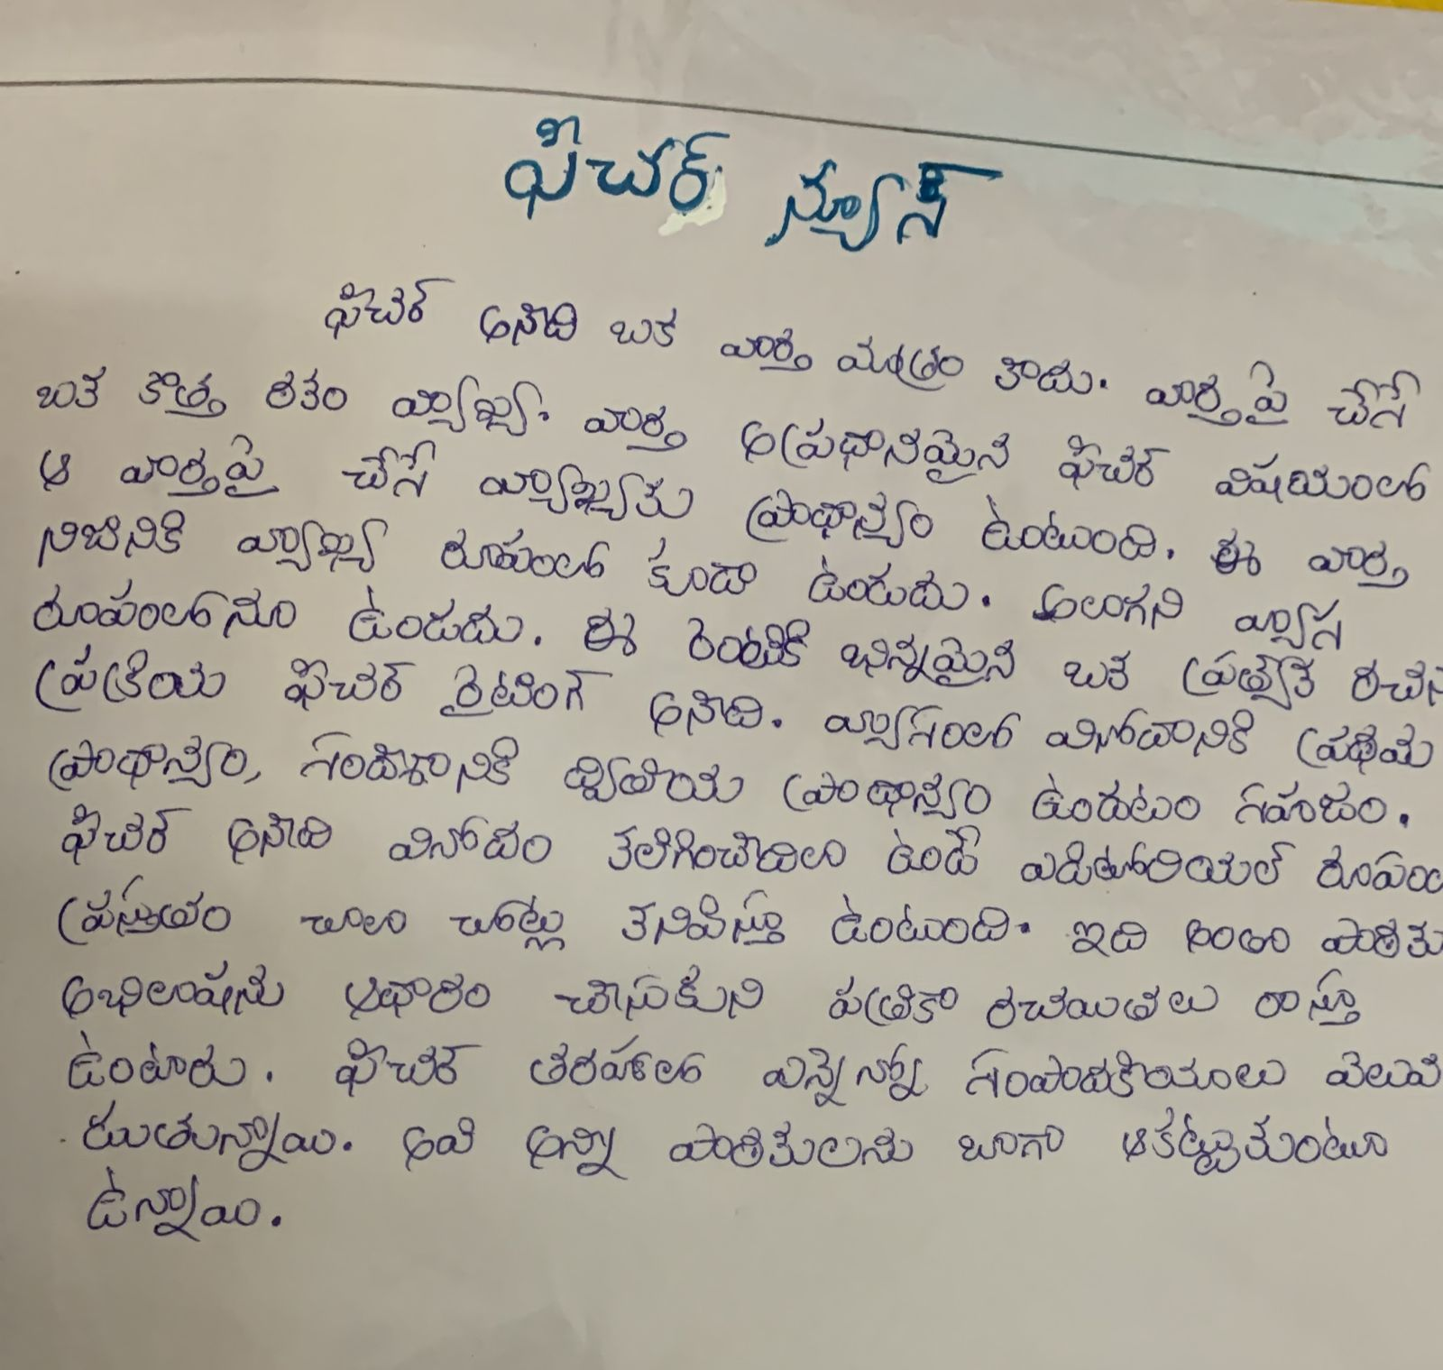
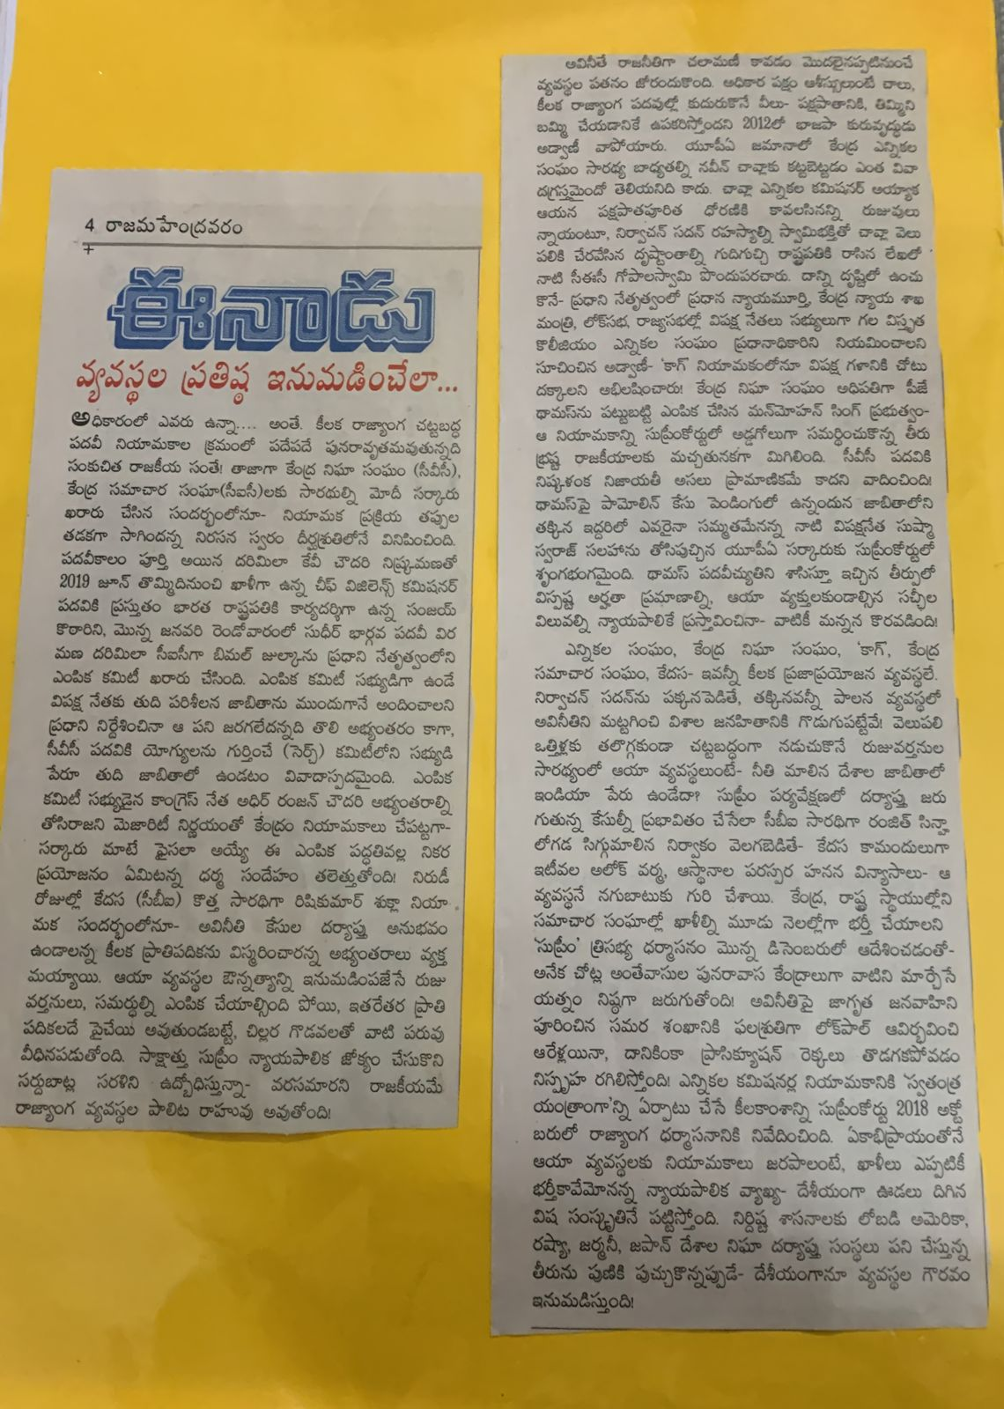

Editorial: Editor wrote Editorial about current major issues in daily News Paper.

Spot News:
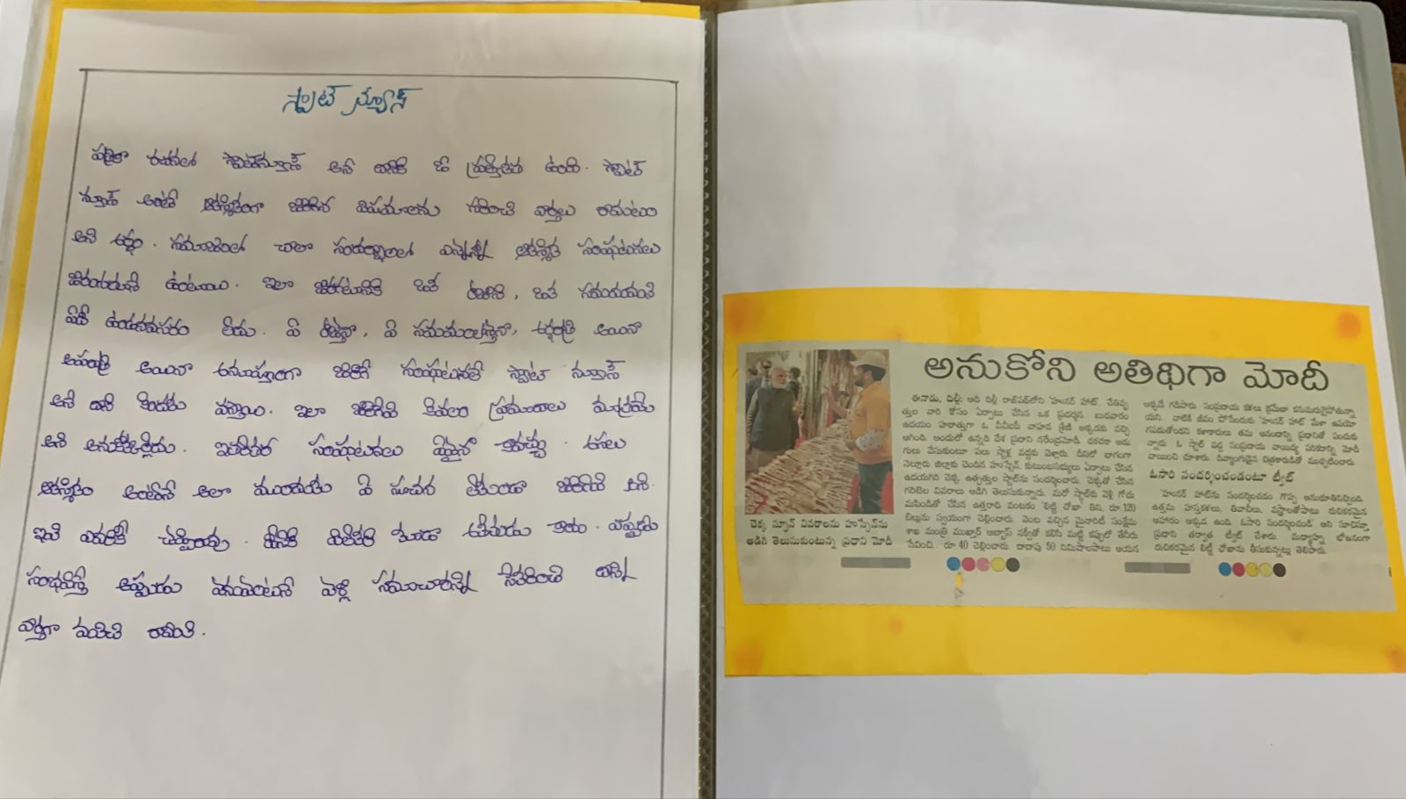
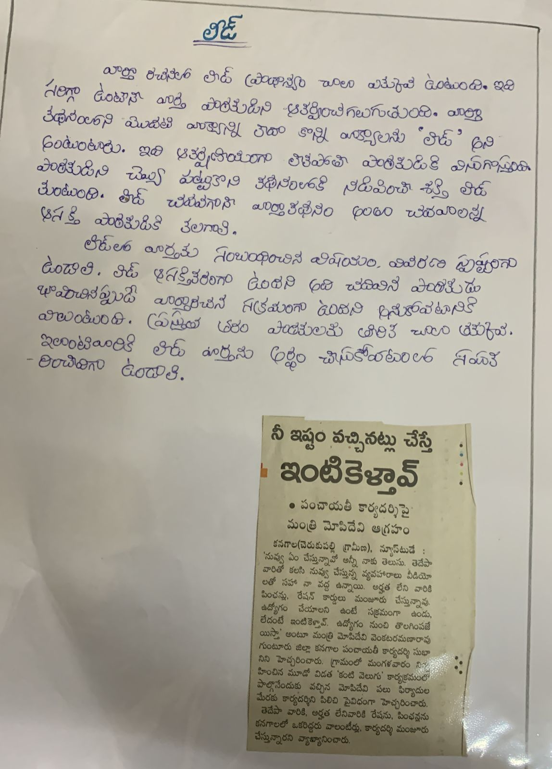

Best Practice-3
Our Departmental another Best Practice is :How to read the Telugu Poem”. Poems Recitation Programme for who interested to learn the Poems. Our faculty member K.S.Annapurnadevi conducted classes for those students ,who want to learn poems.
