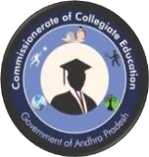
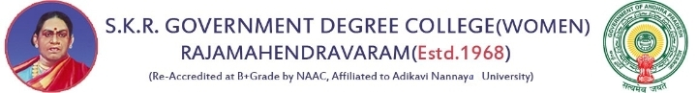

COLLEGE NEWS LETTER
Editorial Board  ChiefEditor:Dr.C.Krishna,SpecialOfficer, | Year 2023
Editor: Dr.P.Raghava Kumari, Principal. | Month: June
Editorial Board Members | Vol: XI
Dr. B. Anuradha Surya Kumari
Incharge of the Department of English Dr. K. Neeraja
Incharge of the Department of Hindi Smt. P. Kusuma Kameswari
Incharge of the Department of Telugu Smt. R. Rajeswari
Incharge of the Department of Sanskrit Smt. P. Sridevi
Incharge of the Department of Botany Student Representatives
S. Richitha, III B. A EEP
P. Anjali, II B.Sc. M.Scs.
E. Tejasri, III BZC
N. Neharika, III B. Com

CONTENTS
ACADEMIC ACTIVITIES

S. No | Date | Name of the Activity | Organized by
1 | 01-6-2023 | Celebrations of the World Environment  Day-1 Plastic Collection | Botany &NSS
2 | 02-6-2023 | Day-2 Rally on Environment Protection | Botany &NSS
3 | 03-6-2023 | Day-3 Bicycle Rally | Botany
4 | 04-6-2023 | Day-4 From Fall to Fertilizer/ Composting ofDry Leaves | Botany &NSS
5 | 05-6-2023 | Day-5 Plantation Programme by Principal | Botany &NSS
6 | 06-6-2023 | Green audit | Botany &NSS
7 | 14-6-2023 | The World Blood Donation Day | NSS
8 | 16-6-2023 | Felicitation to Principal & IntermediateToppers | AP Government
9 | 21-6-2023 | The International Yoga Day | NSS
10 | 23-6-2023 | The International Olympic Day | Physical Education
11 | 26-6-2023 | The International Day against Drug Abuse | YRC
12 | 27-6-2023 | Notification on Online Admissions for Graduation | Principal
13 | 29-6-2023 | National Statistics Day | Mathematics &  Statistics

01-06-2023 :
The World Environment Day Celebrations were enthusiastically organized for five days in SKR Government Degree College for Women under the supervision of Dr. P. Raghava Kumari, Principal and the Department of Botany and NSS Units to raise awareness about plastic pollution and promote responsible waste management for a cleaner and greener environment. As a part of the programme, first day Plastic Collection Drive was organized on campus, with designated points for different types of plastic. Botany Department and NSS volunteers set up bins and displayed posters and banners to educate people about recycling and responsible waste disposal. Dr. P.Raghava Kumari, Principal congratulated the staff members of Botany and NSS Units for their active involvement.
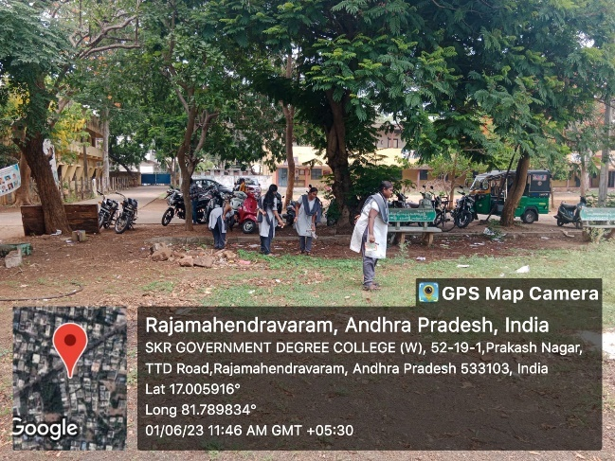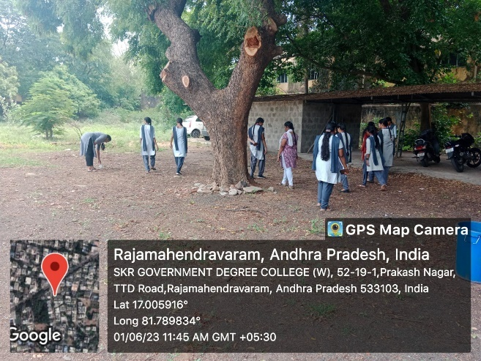

02-06-2023:
As a part of the World Environment Day Celebrations in SKR Government Degree College for Women, Rajahmundry, second day the Department of Botany and NSS Units organized a grand Environment Protection Rally on 02-6-2023.The event aimed to raise awareness among students and the community about the importance of safeguarding the environment and fostering sustainable practices. The rally was led by the Department of Botany and NSS Units. It proceeded through the main streets of the city. Participants carried banners and placards bearing powerful messages urging for environmental protection. Dr.P.Raghava Kumari appreciated the volunteers, staff and students for their commitment and active participation.

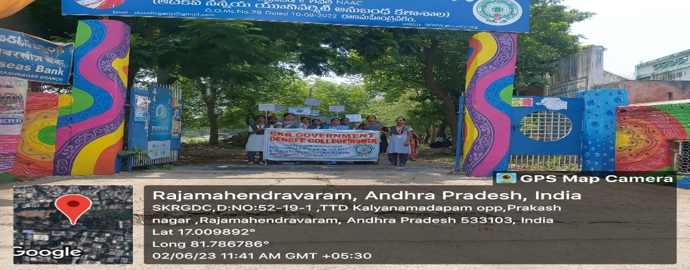
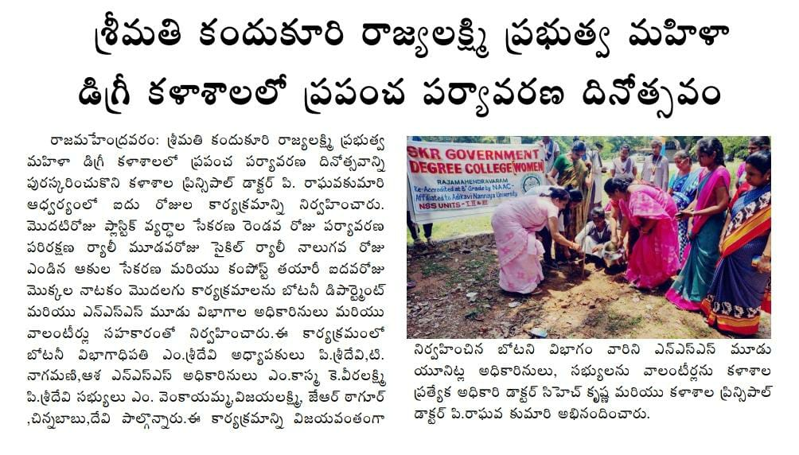

03-6-2023
As a part of the World Environment Day Celebrations in SKR Government Degree College for Women, Rajahmundry, third day the Department of Botany and NSS Units organized a Bicycle Rally on 03-6-2023 to raise awareness about eco-friendly transportation and promote sustainable practices among the students and staff. Students and NSS volunteers participated and enjoyed the programme. Dr.P.Raghava Kumari appreciated the initiatives taken by the Department of Botany and NSS Units .

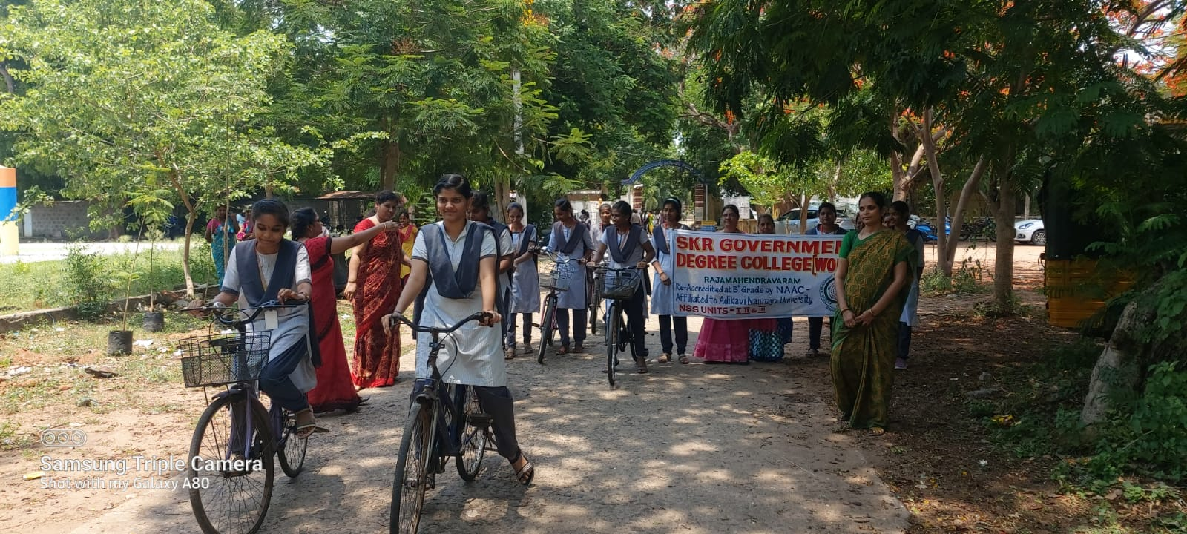

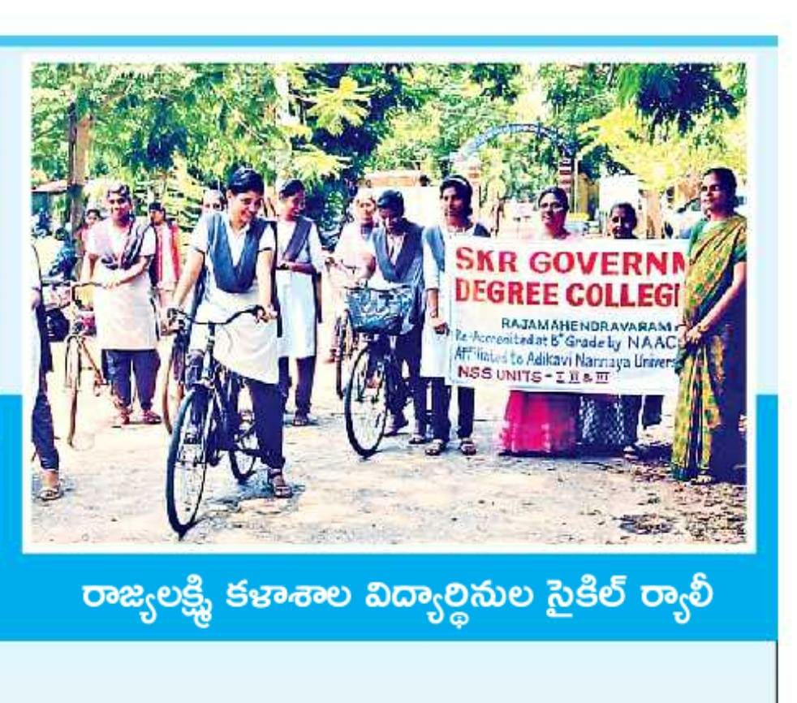
04-6-2023
As a part of the World Environment Day Celebrations in SKR Government Degree College for Women, Rajahmundry, fourth day the Department of Botany and NSS Units organized a programme on Composting of Dry Leaves/From Fall to Fertilizers on 04-6- 2023 to promote eco-friendly waste management and nutrient-rich compost for college gardens. The project aimed to raise awareness about the environmental benefits and encourage active participation from students, faculty, and staff. Dr.P.Raghava Kumari congratulated the Department of Botany, students and NSS Units for undertaking such an initiative as it not only demonstrated the importance of responsible waste management but also encouraged active participation from the college community. It might be a small but significant step towards creating a greener and more sustainable campus environment. She also felt that it would inspire more such environmentally friendly projects in the future.

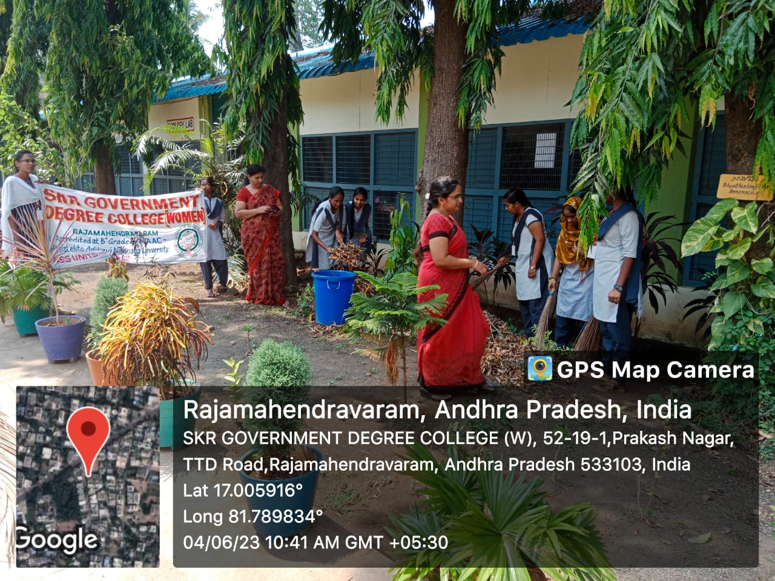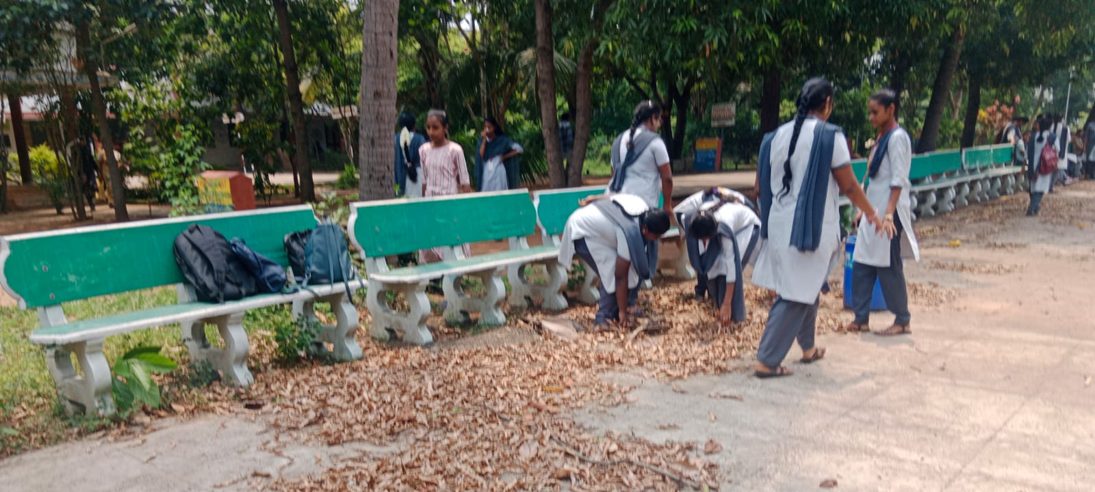

05-6-2023:
As a part of the World Environment Day Celebrations in SKR Government Degree College for Women, Rajahmundry, fifth day the Department of Botany and NSS Units organized a PlantationProgramme on 05-6- 2023.to promote green initiatives, raise awareness about the importance of trees, and contribute to the beautification of our campus. The plantation programme aimed to inspire students, faculty, and staff to actively participate in the conservation of nature and to instill a sense of responsibility towards the environment. The primary objective of the plantation programme was to increase the green cover on our college campus, enhance biodiversity, and create a sustainable environment for future generations. Additionally, it aimed to foster a sense of community involvement and pride in contributing to the preservation of nature.Dr.P. Raghava Kumari, Principal planted some saplings and motivated the staff and students. She felt that the programmewould serve as a stepping stone for future sustainability efforts and inspire others to embrace similar green initiatives for a greener and healthier planet. She congratulated the team for organizing the programme.
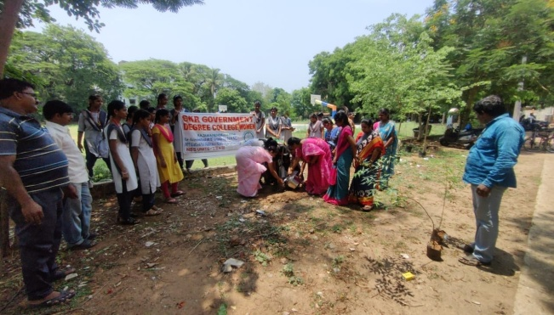

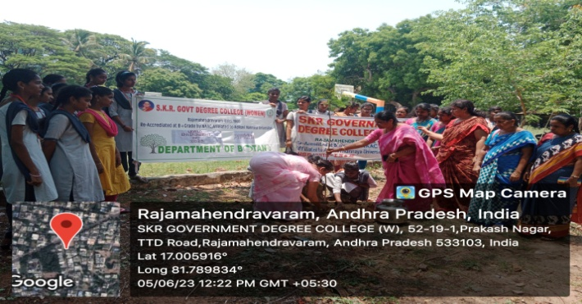

06-6-2023
Green Audit:
The purpose of a green audit is to assess and analyze the environmental impact and sustainability practices of an organization or individual to promote eco-friendly and resource-efficient operations. Plant Survey was conducted from June 6th to 30th June 2023 by the Department of Botany. Students of II year BZC along with Botany staff collected plant data every day on the assigned topics related to the green audit prepared the number of herbs, shrubs, trees, climbers and creepers lists and made name plates for plants. Finally it was identified that more than 203 species of plants are in the college campus. Out of 203 species, there are 68 trees, 66 shrubs, 54 herbs, 15 creepers & climbers. Dr. P.Raghava Kumari congratulated the Department of Botanyfor their sincere efforts and fruitful outcomes.
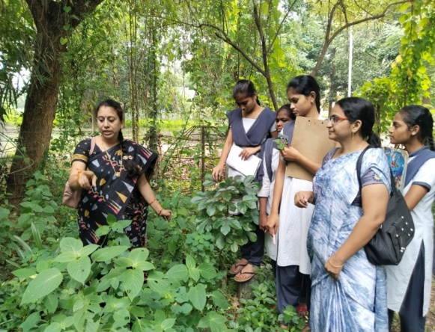
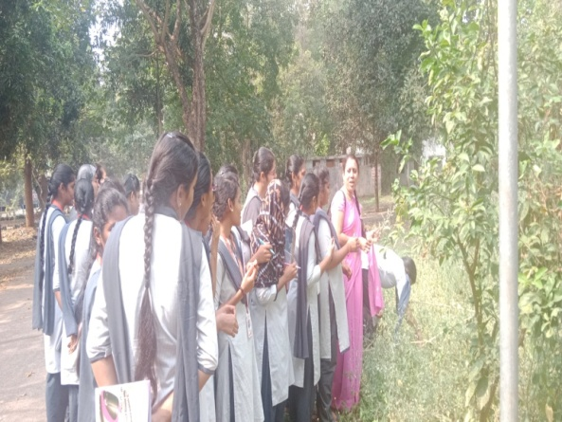

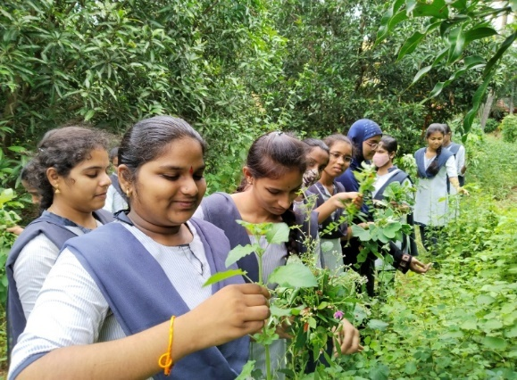
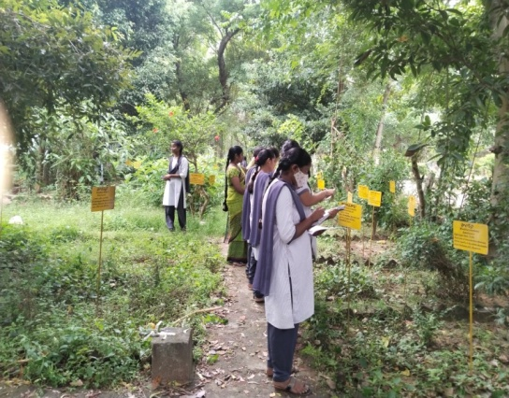

14-6-2023
The World Blood Donation Day was organized by NSS Units in SKR Government Degree College for Women on 14-6-2023. celebrated globally to raise awareness about the importance of voluntary blood donation and to appreciate the selfless donors who save lives through their contributions. It was a special event to commemorate this meaningful day and encourage students and staff to come forward and donate blood. It aimed to create awareness among the college community about the critical need for blood donations and to promote a culture of voluntary donation. Many students and staff members actively participated in the Rally, showcasing their concern for society and their willingness to contribute to a noble cause. The Rally raised awareness among the public about the significance of regular and voluntary blood donations. Dr. P.Raghava Kumari, Principal strongly believes that organizing such events, the college community became more conscious of the importance of donating blood regularly and its life-saving impact. Shealso opined that such events sparked an interest in social responsibility and philanthropy, encouraging students to participate in future initiatives aimed at making a positive impact on society. She appreciated the three NSS Units for the programme.
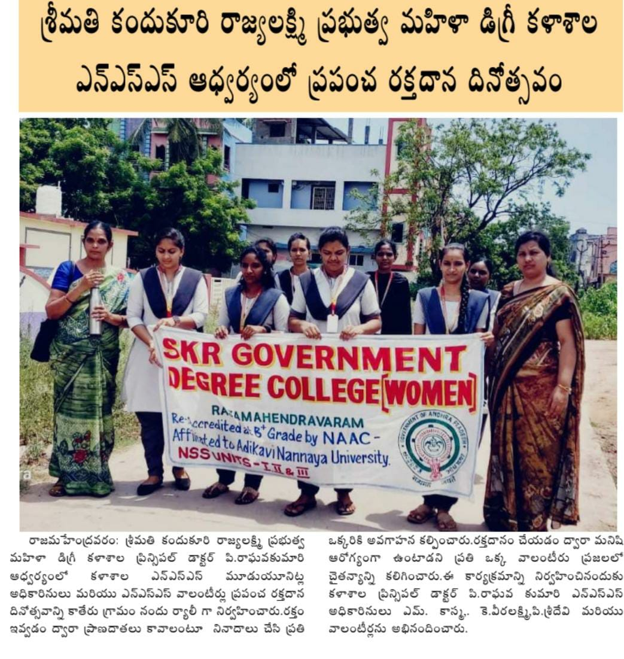

16-6-2023:
Students achieved remarkable success in the Intermediate examinations. Their determination, coupled with the guidance of dedicated teachers and the resources from the initiative, enabled them to secure top ranks across various streams. These extraordinary performances showcased the untapped talent present in our local community.Results from the Intermediate exams are an important turning point for students, and receiving high marks is evidence of their commitment and hard work coupled with the guidance of dedicated teachers, enabled them to secure top ranks across various streams. These extraordinary performances showcased the untapped talent present in the students of SKR Government Degree College for Women, Rajahmundry. When a grp of extraordinarily gifted students achieved top rankings in the Intermediate Examinations, it was a significant event in the college . Their exceptional performances caught the attention of the State Government, leading to a felicitation ceremony in their honour along with the Principal Dr.P.Raghava Kumari. Principal Dr.P.Raghava Kumari congratulated and appreciated the toppers and said that the achievement of top rankers in the Intermediate examinations and their felicitation by the AP State is a testament to the potential that lies within local communities. She felt that with that support, talented students can overcome financial constraints and achieve remarkable success in their academic pursuits.
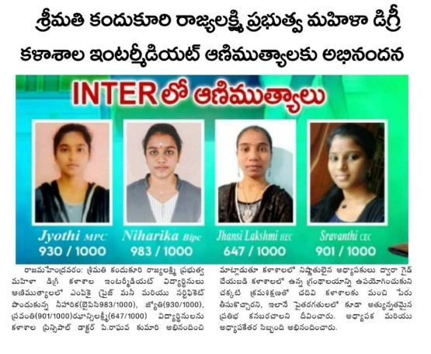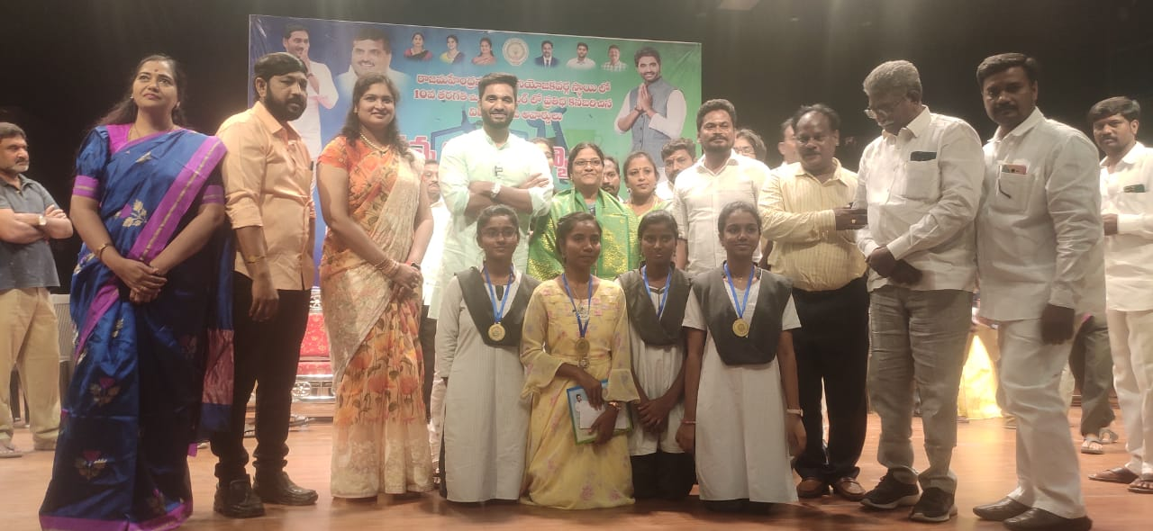

21-6-2023:
The International Yoga Day was organized by NSS Units in SKR Government Degree College for Women on 21-6-2023. It was celebrated globally to promote the physical, mental, and spiritual well-being of individuals through the practice of yoga. PrincipalDr.P.RagahavaKumari , staff and enthusiastically joined the global celebrations to mark the special day with a series of activities aimed at promoting the benefits of yoga among students and staff. The day began with a yoga workshop conducted by certified yoga instructorSmt. P.Anantha Lakshmi.The workshop focused on introducing various yoga asanasand pranayamas to the participants. Students and faculty members actively participated in the workshop, learning the basics of yoga and its positive pe impact on health. Principal Dr.P. Raghava Kumari, staff and students and NSS volunteers enthusiastically participated in the programme.
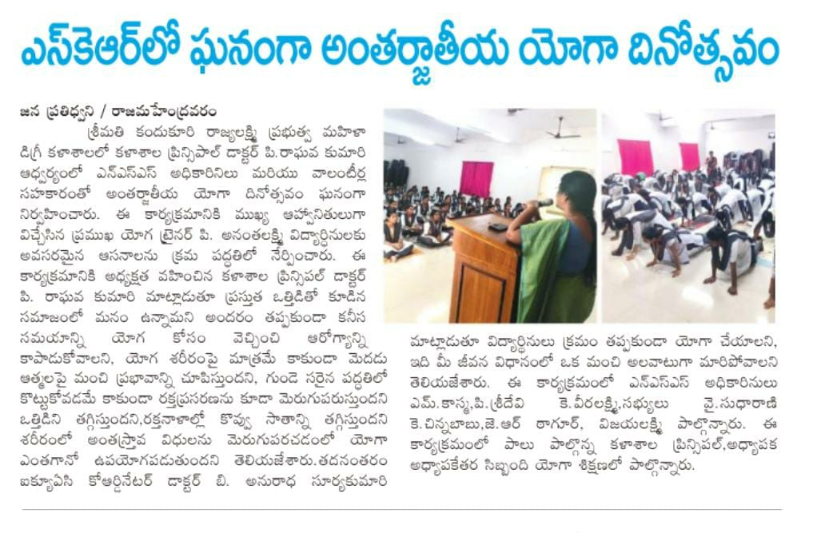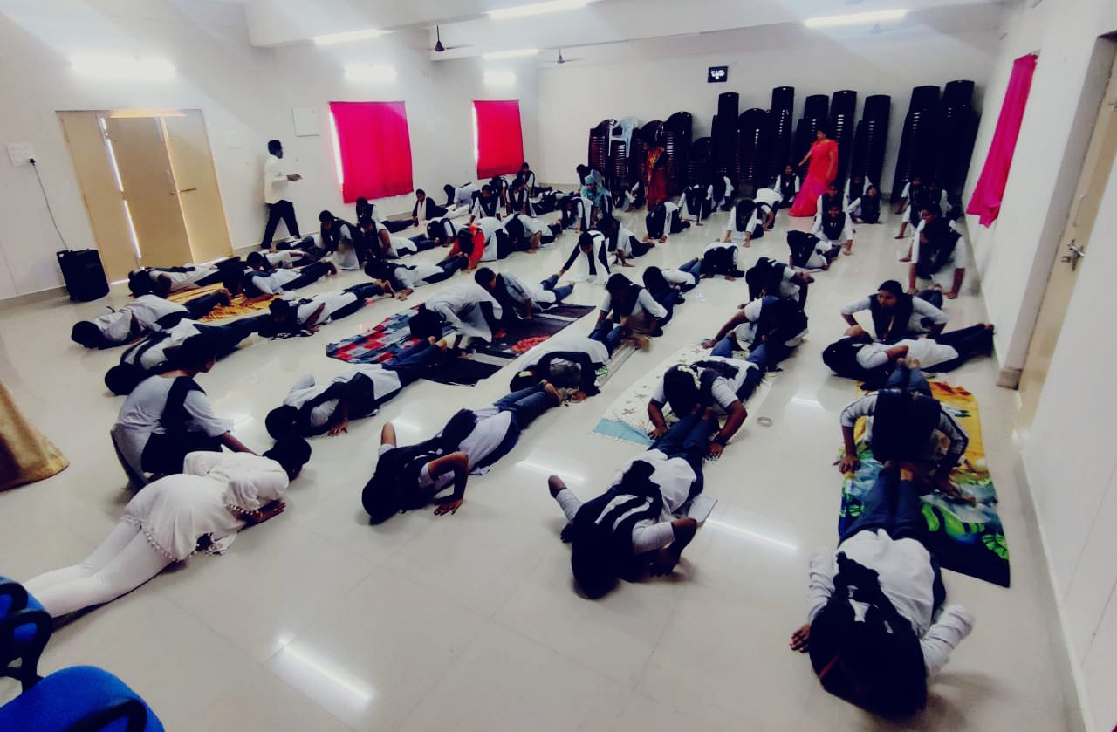
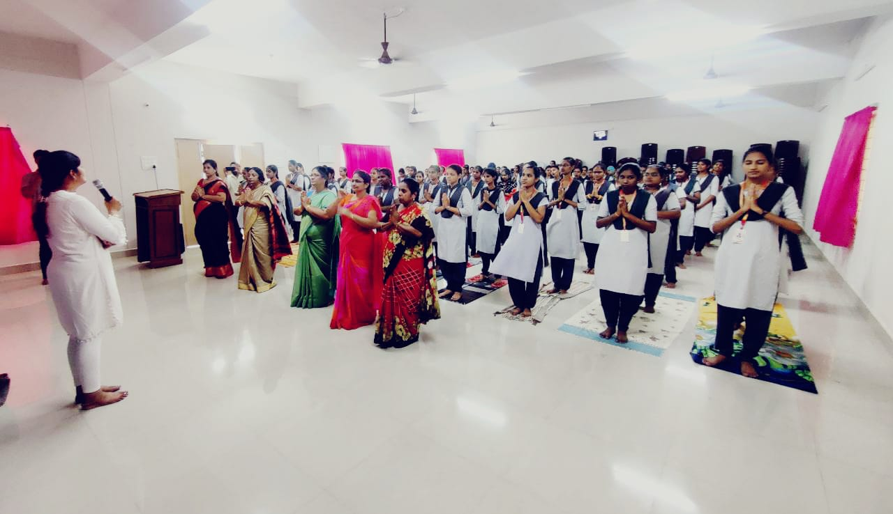

23-6-2023:
The International Olympics Day was organized by the Physical Education Department in SKR Government Degree College for Women on 23-6-2023. It joined the global celebrations to mark the special day with a range of activities aimed at encouraging students and faculty to embrace the Olympic spirit and engage in sports and physical activities. As a part of the Programme, Running Race was conducted. Principal Dr.P.Raghava Kumari, Y.Sudha Rani, Physical Director, staff and students participated in the programme.The International Olympic Day celebration at thecollege sparked enthusiasm and excitement, emphasizing the importance of integrating sports and physical activities into academic and extracurricular programs. It inspired students to embrace the sports and physical activities, motivating to promote sports and fitness on campus, nurturing future athletes, and fostering a culture of athleticism and sporting spirit.
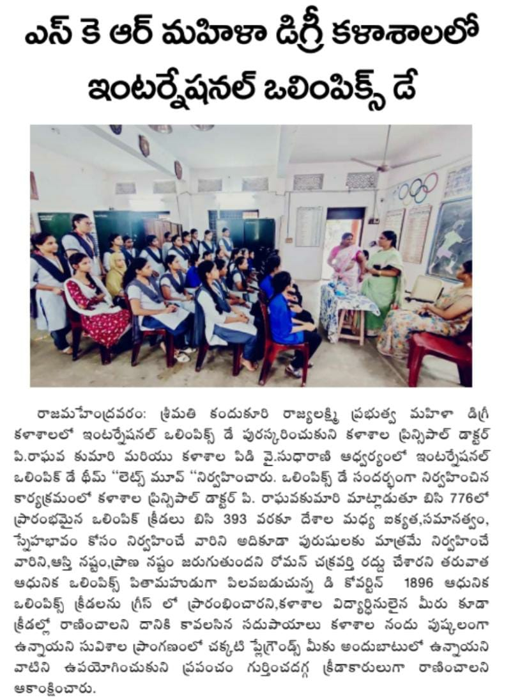
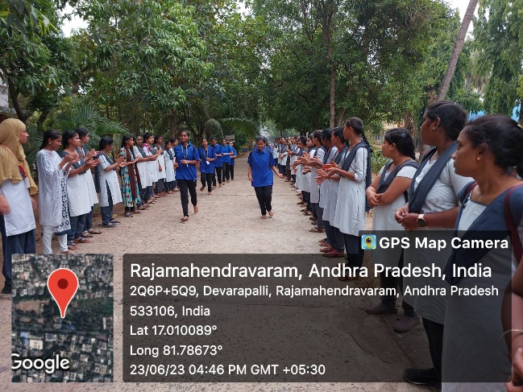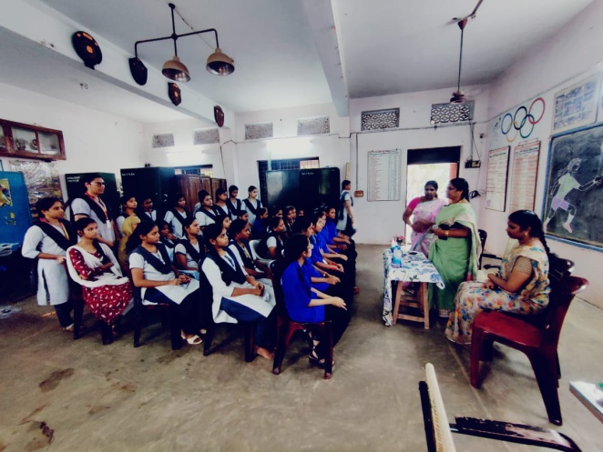
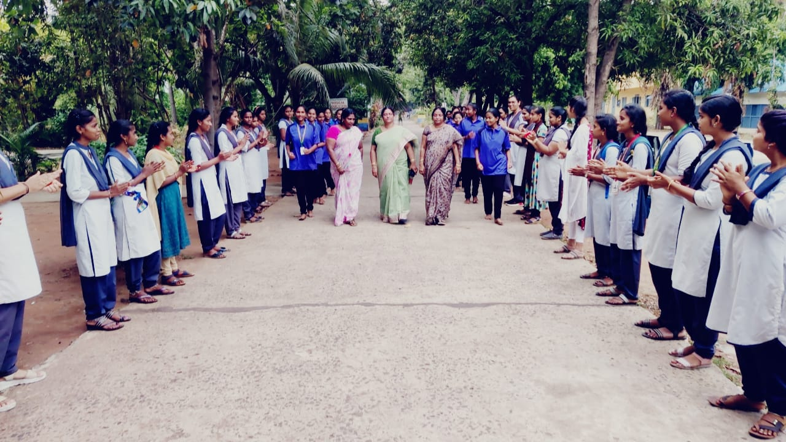

26-6-2023
The International Day against Drug Abuse was organized by YRC in SKR Government Degree College for Women on 26-6-2023. Every year on June 26th, the world comes together to mark the International Day Against Drug misuse and Illicit Trafficking, which aims to increase awareness of the problem of drug misuse worldwide and the harm it causes to both individuals and society. With the goal of addressing the problem of drug usage among students, An Awareness Programme by Sri.Sankara Raooffered helpful insights on the frequency of drug abuse, its effects on physical and mental health, and the significance of getting help for people who are battling with them. He also advised the students to be careful of mobile phones. Principal, Dr.P.Raghava Kumari congratulated the YRC team for organizing such a useful programme.
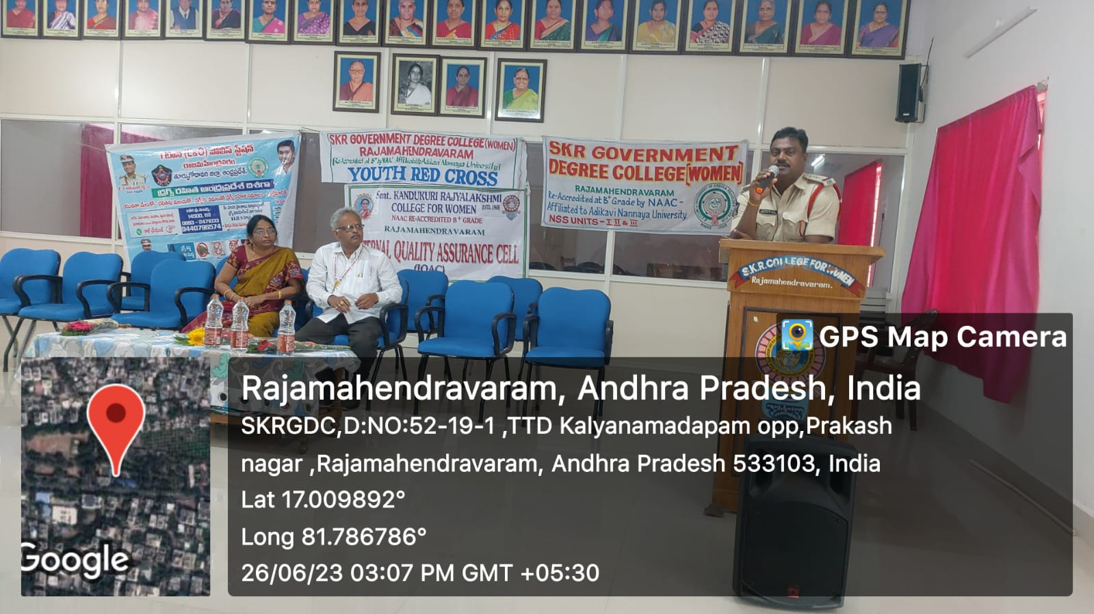
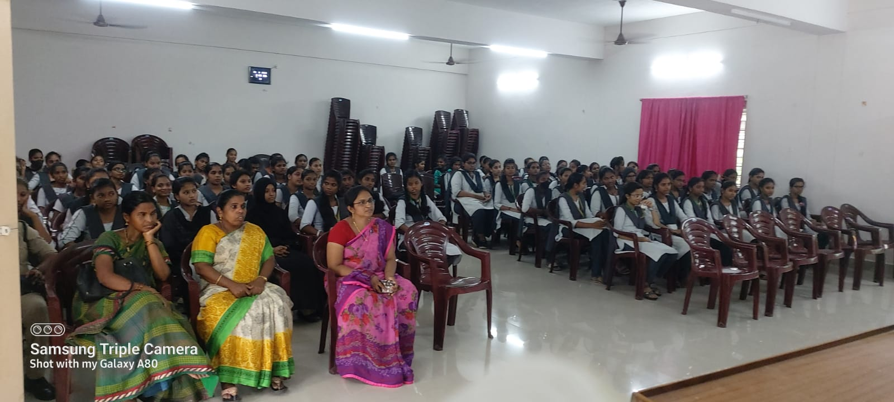
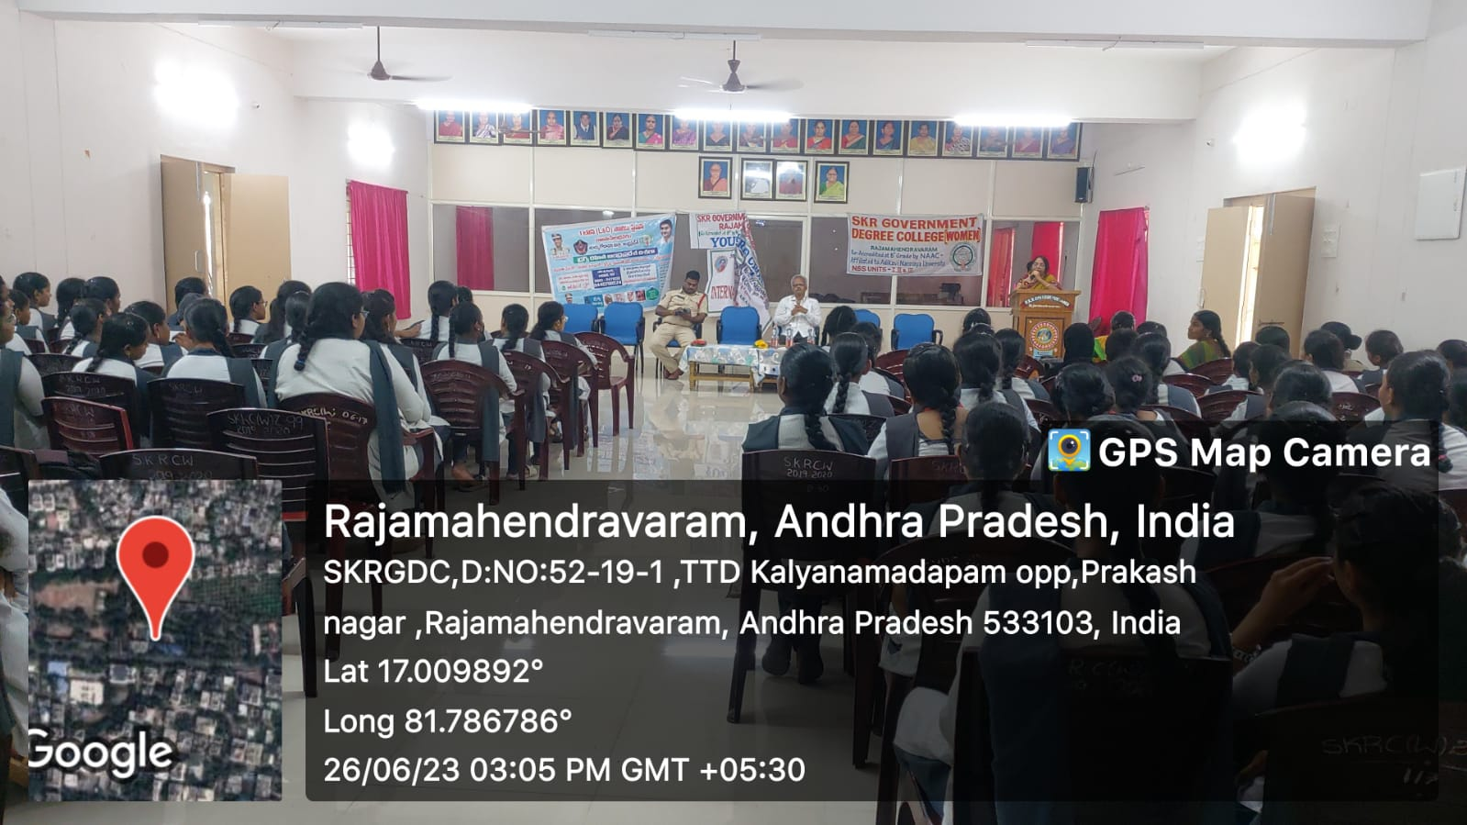
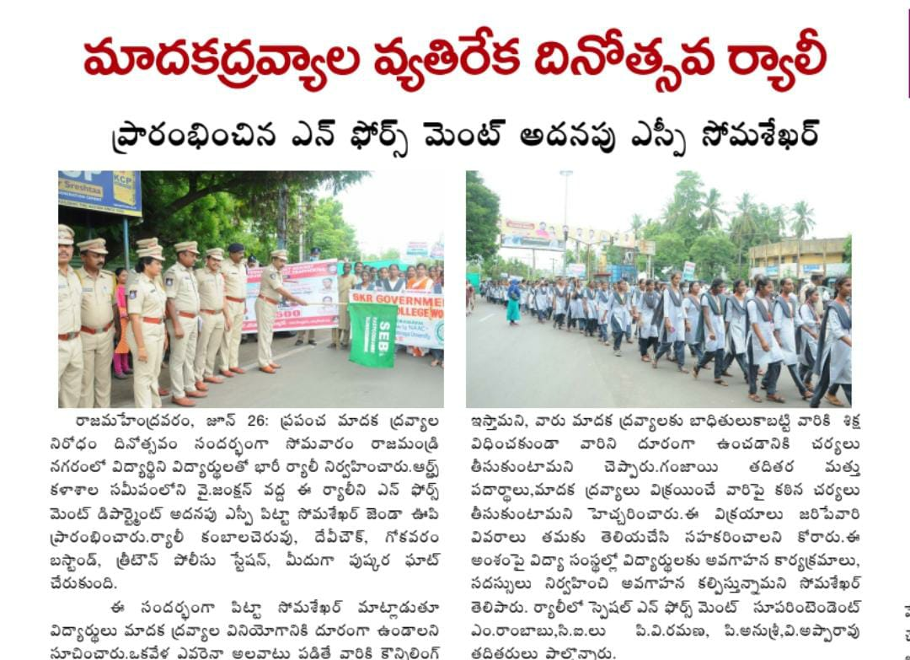

27-6-2023
Notification on OnlineAdmissions for Graduation was given by SKR Government Degree College for Women, Rajahmundry. The schedulewas announced by Dr.P.Raghava Kumari, Principal.
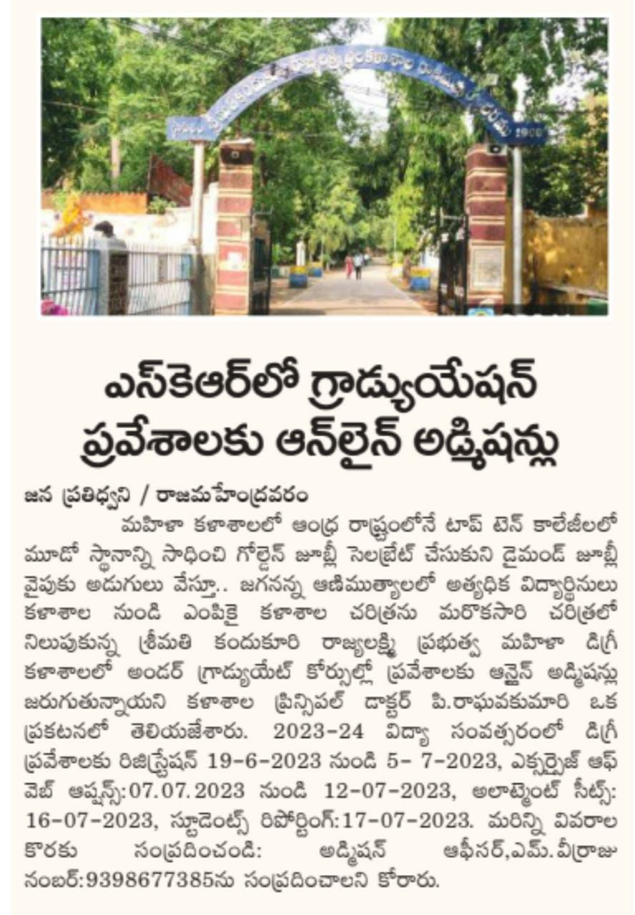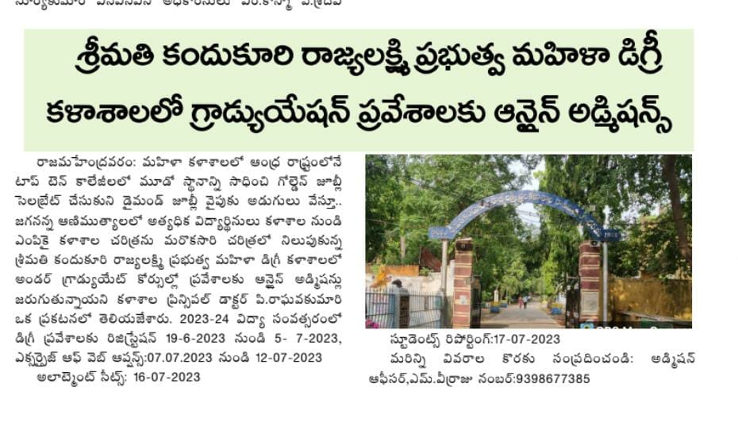

29-6-2023
National Statistics Day was observed in SKR Government Degree College, Rajahmundry by the Department of Mathematics and Statistics on the occasion of great Indian StatistianProf.Prasantha Chandra Mahalanobis's Birth Anniversary on 29th Assistant Statistical Officer Sri D. Bagavan Das attended as the Cheif Guest and the programme was presided over by the college Principal Dr. P. Raghava Kumari and IQAC Coordinator Dr.Anuradha, Staff, 1st year and 2nd year BSc students attended the programme . A Quiz on the topic Statistics was conducted and prizes were distributed by the Cheif Guest to the participants who got highest marks .
